Table of Contents
Lab 1: Creating Table using oracle interface 1
Lab 2: Creating Tables using DDL Queries in SQL 4
Lab 3: Insert, Update and Delete values in the Table using the DML 4
Lab 4: The practice of DDL and DML queries with different case scenarios 4
Lab 5: Where and Order by clause 4
Lab 6: Other restricting data constraints 4
Lab 7: Practical Test (Create, Alter, Drop, Insert, Update, Delete) 4
Lab 8: Database setup using Xampp 4
Lab 9: MySQL DDL queries using different scenarios 4
Lab 10: MySQL DML queries using different scenarios 4
Lab 11: Practical Test (Create Database and Table, Alter, Drop, Insert, Update, Delete, Where, Order By and Other Restricting Data Constraints) 4
Lab 12: Join (Cross, Inner and Outer Join (Left, Right, Full)) 4
Lab 13: Join (Self and Multiple) 4

Lab No 1 : Create Table Using Oracle GUI
Task: Creating Table(STD_INFO) in Oracle with GUI
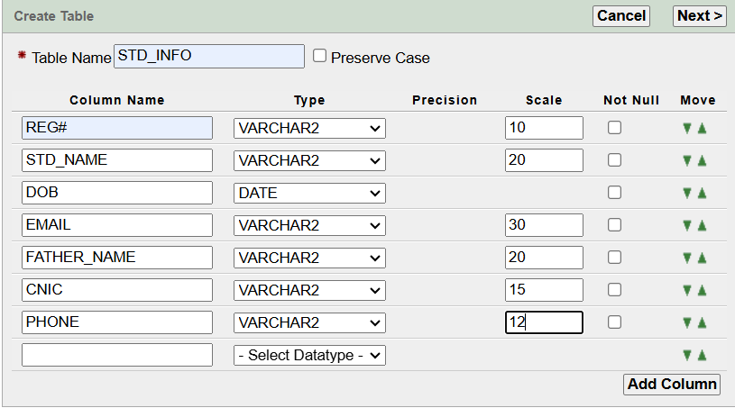

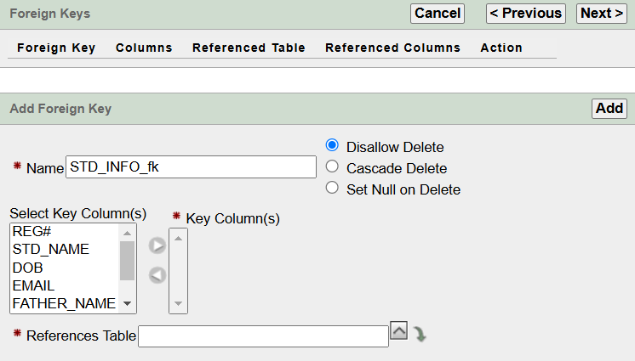
Figure 1.3: Setting Foreign Key
Figure 1.2: Setting Primary Key
Figure 1.1: Entering Values In Table

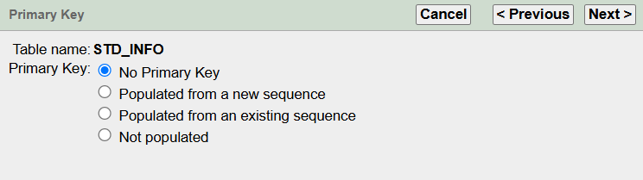

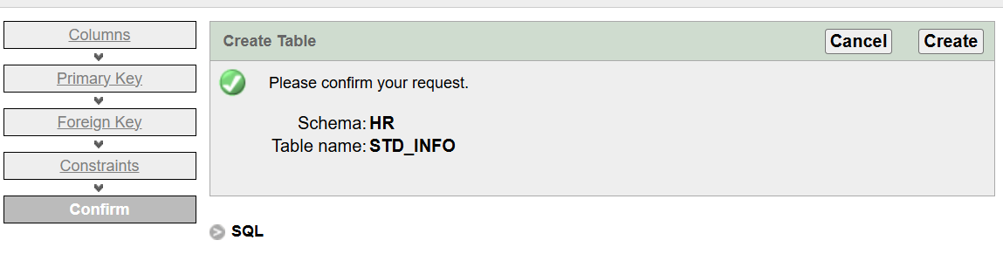
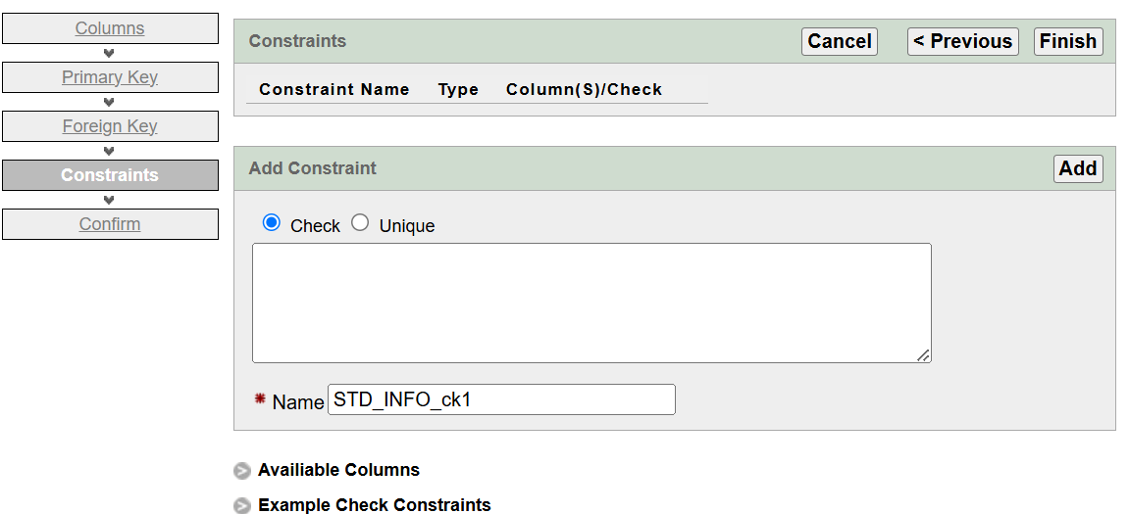
Figure 1.5: Confirming our Table and Creating it
Figure 1.4: Setting Constraints

Lab No 2: Create Table Using Data Definition Language (DDL) Commands
Task No. 1: Creating Table using CREATE Command
Task No. 1.1: Creating Table TUF_STUDENTS
CREATE QUERY:-
CREATE TABLE TUF_STUDENTS(
STD_ID NUMBER(9),
STD_NAME VARCHAR2(20),
STD_FNAME VARCHAR2(20),
STD_DOB DATE,
STD_EMAIL VARCHAR2(30),
STD_ADDRESS VARCHAR2(100),
STD_PHONE NUMBER(12));

DESCRIBE QUERY:-
DESCRIBE TUF_STUDENTS
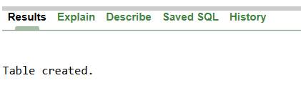

Figure 2.1: TUF_STUDENTS Table Created

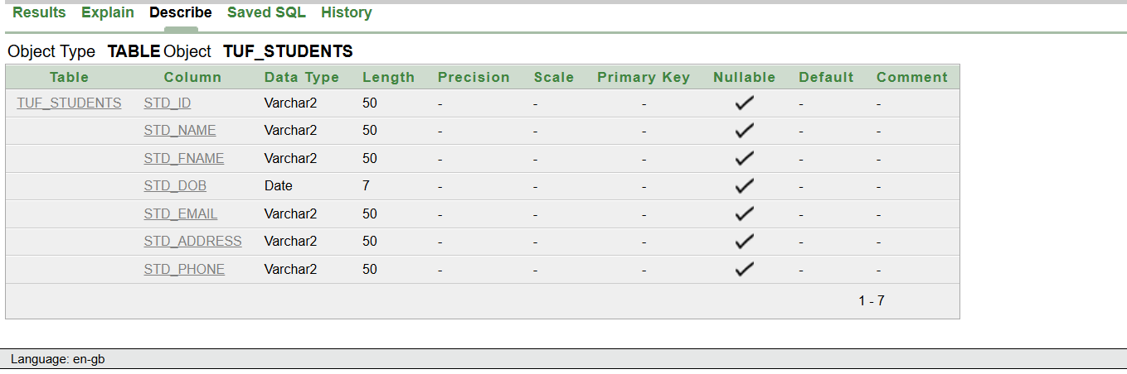

Figure 2.2: Describing TUF_STUDENTS
Task No. 1.2: Creating Table PLAYER_STATS
CREATE QUERY:-
CREATE TABLE PLAYER_STATS (
PLAYER_ID NUMBER,
PLAYER_NAME VARCHAR2(100),
SPORT_TYPE VARCHAR2(50),
TEAM_NAME VARCHAR2(100),
GAMES_PLAYED NUMBER,
TOTAL_POINTS NUMBER,
ASSISTS NUMBER
);
DESCRIBE QUERY:-
DESCRIBE PLAYER_STATS

Figure 2.3: YARN_STOCK Table Created

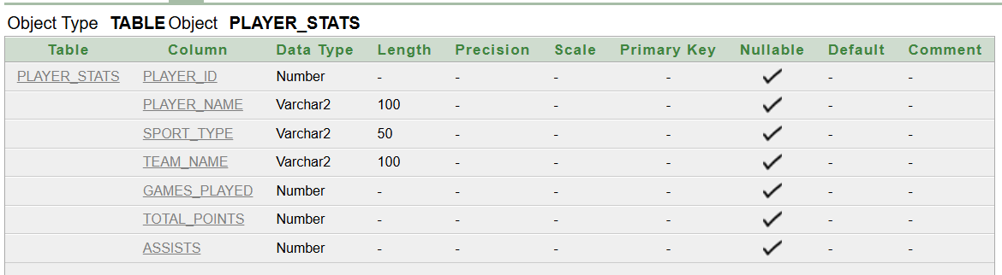

Figure 2.4: Describing PLAYER_STATS
Task No. 1.3: Creating Table LOGIN_PAGE
CREATE QUERY:-
CREATE TABLE LOGIN_PAGE(
ID VARCHAR2(50),
USERNAME VARCHAR2(50),
PASSWORD VARCHAR2(50)
);

DESCRIBE QUERY:-
DESCRIBE LOGIN_PAGE

Figure 2.5: LOGIN_PAGE Table Created

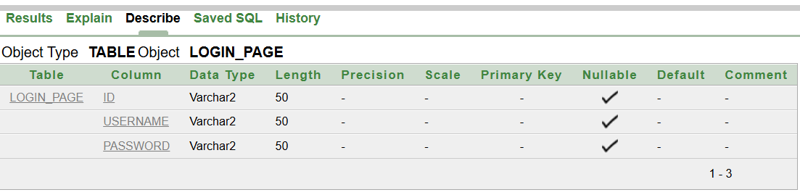

Figure 2.6: Describing LOGIN_PAGE

Task No. 2: Making Changes to Table using ALTER Command
Task No. 2.1: Using ADD Command
ADD QUERY:-
ALTER TABLE TUF_STUDENTS
ADD STD_PERMANENT_ADDRESS VARCHAR2(100);
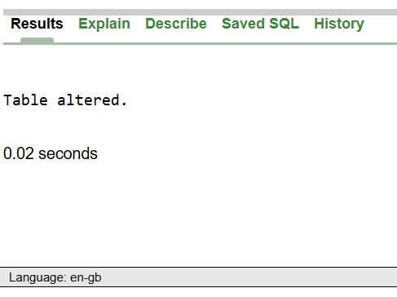
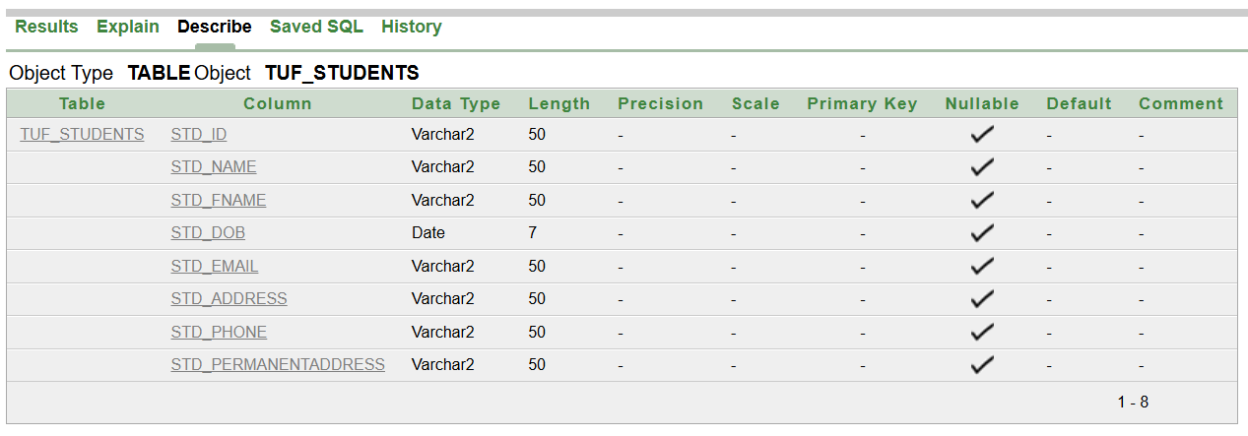
Figure 2.7: TUF_STUDENTS Table Altered

Figure 2.8: TUF_STUDENTS Table After Adding STD_PERMANENTADDRESS

Task No. 2.2: Using MODIFY Command
MODIFY QUERY:-
ALTER TABLE TUF_STUDENTS
MODIFY STD_EMAIL CHAR(30);
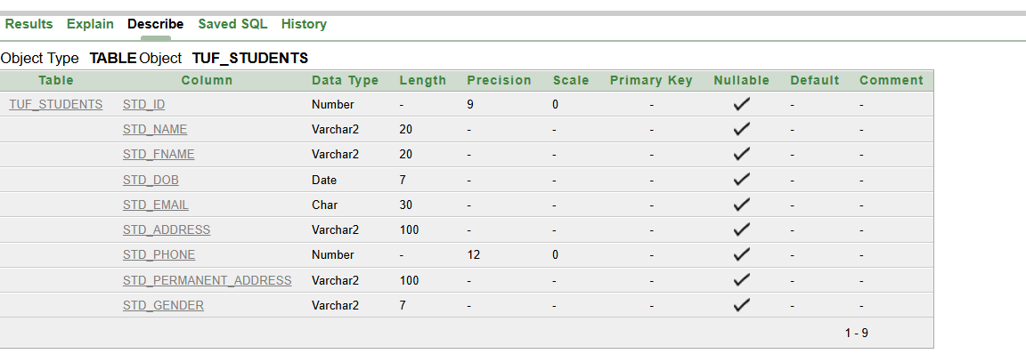

Figure 2.9: TUF_STUDENTS Table After Modifying Email Column

Task No. 2.3: Using RENAME Command For Column Renaming
RENAME QUERY:-
ALTER TABLE TUF_STUDENTS
RENAME COLUMN STD_ADDRESS TO STD_TEMPORARY_ADDRESS;
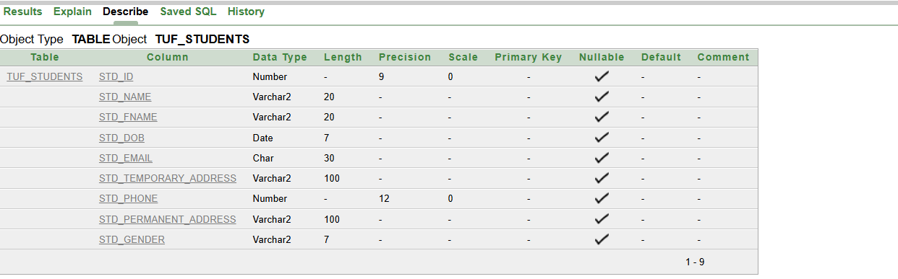

Figure 2.10: TUF_STUDENTS Table After Renaming STD_ADDRESS Column
Task No. 2.4: Using DROP Command for Dropping Column
DROP QUERY:-
ALTER TABLE TUF_STUDENTS
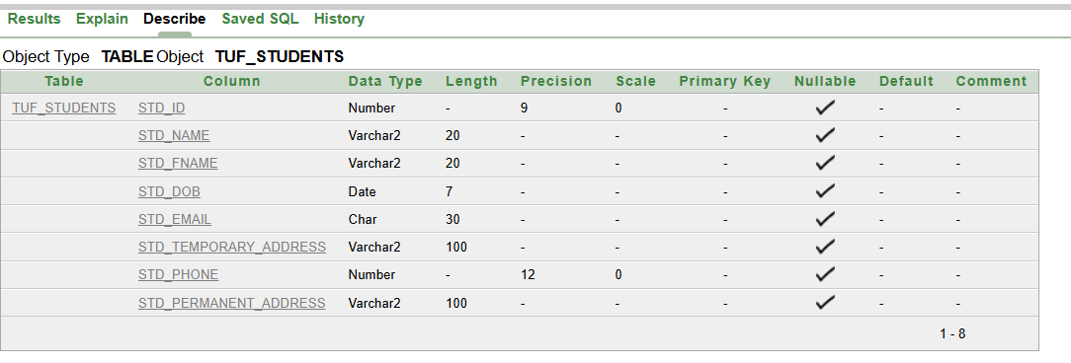
DROP COLUMN STD_GENDER;

Figure 2.11: TUF_STUDENTS Table After Dropping STD_GENDER Column

Task No. 3: Renaming whole Table using RENAME Command
RENAME QUERY:-
RENAME TUF_STUDENTS TO TUF_BSAI4
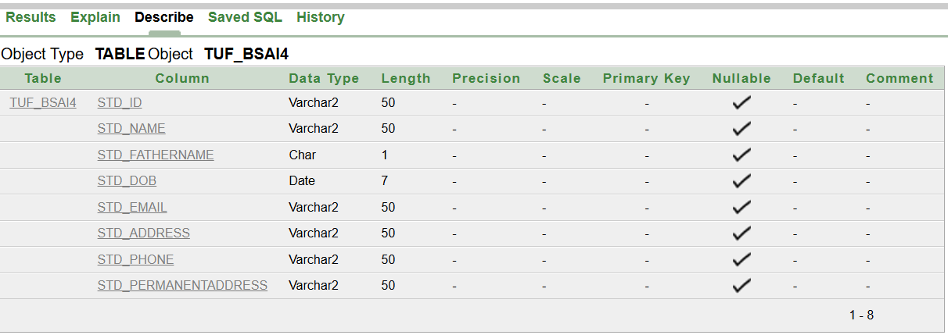

Figure 2.11: TUF_STUDENTS Table After Renaming to TUF_BSAI4

Task No. 4: Deleting whole Table using DROP Command
DELETE QUERY:-
DROP TABLE LOGIN_PAGE;
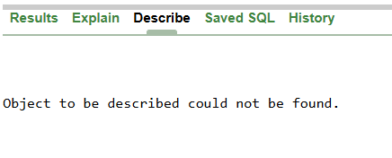
Figure 2.12: LOGIN_PAGE Table After Being Dropped

Lab No 3: Insert, Update, Delete Table Data using DML
Task No. 1: Inserting Values in the Table using INSERT Command
INSERT QUERY:-
INSERT INTO STD_RESULT(STD_ID,STD_NAME,SUBJ_NAME,SUBJ_MARKS,SUBJ_GRADE,SUBJ_GPA)
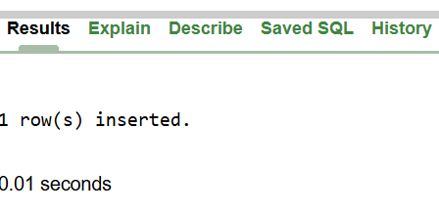
VALUES (032,'HASEEB','DBMS',80,'A',3);

Figure 3.1: STD_RESULT Table After Values Inserted

SELECT QUERY:-
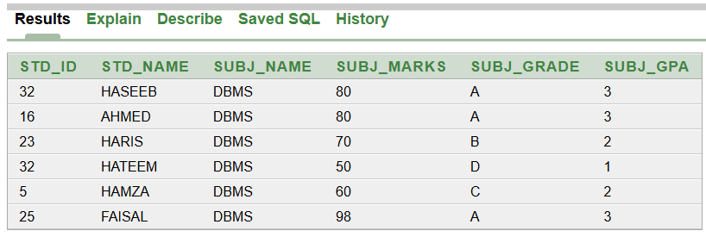
SELECT* FROM STD_RESULT
Figure 3.2: Viewing STD_RESULT Table

Task No. 2: Inserting Multiple Values in the Table using INSERT ALL Command
INSERT ALL QUERY:-
INSERT ALL
INTO TUF_BSAI4 VALUES (03, 'HASHIR', 'A', TO_DATE('11-05-2004', 'DD-MM-YYYY'), 'HASHIR@GMAIL.COM', '43-C', '03247758001', 'D120')
INTO TUF_BSAI4 VALUES (04, 'HARIS', 'A', TO_DATE('12-04-2004', 'DD-MM-YYYY'), 'HARIS@GMAIL.COM', '190-B', '03247758001', '190B')
INTO TUF_BSAI4 VALUES (01, 'FAISAL', 'K', TO_DATE('16-01-2004', 'DD-MM-YYYY'), 'FAISAL@GMAIL.COM', '194-C', '03247758001', '63-C')
INTO TUF_BSAI4 VALUES (02, 'HATEEM', 'T', TO_DATE('16-03-2004', 'DD-MM-YYYY'), 'HATEEM@GMAIL.COM', '63-C', '03247758001', '190B')
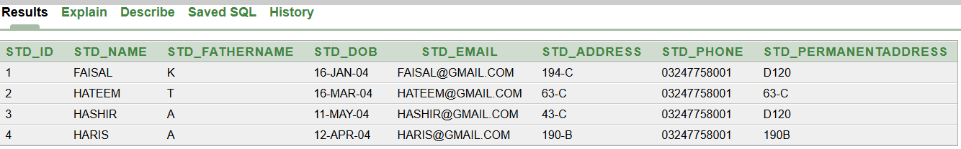
SELECT * FROM DUAL;

Figure 3.3: Viewing STD_RESULT Table With Multiple Values

Task No. 3: Update Table using UPDATE Command
Task No. 3.1: Updating All Values Of Table
UPDATE QUERY:-
UPDATE TUF_BSAI4 SET STD_NAME='ABC';
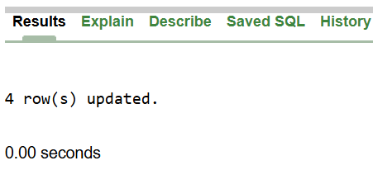

Figure 3.4: Updated All Values of TUF_BSAI4 Table

SELECT QUERY:-
SELECT* FROM STD_RESULT
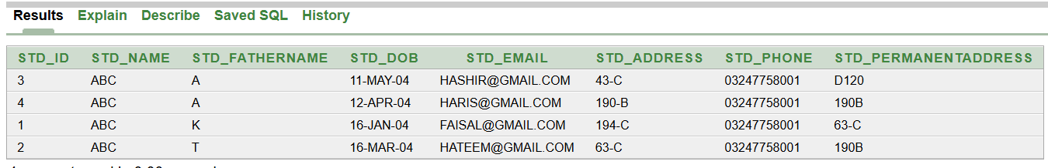

Figure 3.5: Updated TUF_BSAI4 Table

Task No. 3.2: Updating Specific Values Using WHERE Command
UPDATE QUERY
UPDATE TUF_BSAI4 SET STD_NAME='XYZ' WHERE STD_ID=3;
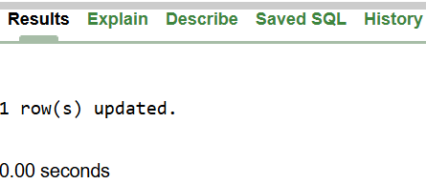

Figure 3.6: Updated All Values of TUF_BSAI4 Table

SELECT QUERY:-
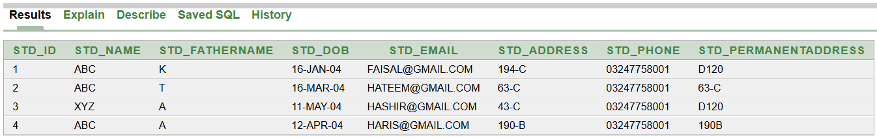
SELECT* FROM STD_RESULT
Figure 3.7: Updated Specific Values Of TUF_BSAI4 Table

Task No. 4: Deleting Table Values using DELETE Command
Task No. 4.1: Deleting All Values Of Table Using DELETE Command
DELETE QUERY:-
DELETE TUF_BSAI4;
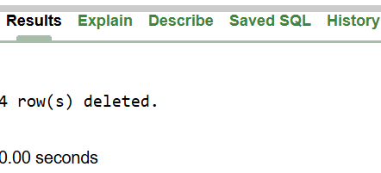

Figure 3.8: Deleted All Values of TUF_BSAI4 Table

Task No. 4.2: Deleting Specific Values Using DELETE Command
DELETE QUERY:-
DELETE TUF_BSAI4 WHERE STD_ID=3;
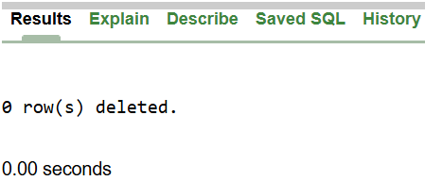
Figure 3.9: Deleted Specific Values Of TUF_BSAI4 Table

Lab No 4: The practice of DDL and DML queries with different case scenarios
Scenario No. 1: Managing Employee Records in a Company
Task No. 1: Creating a table for employees
CREATE QUERY
CREATE TABLE EMPLOYEE_NEW(
EMPLOYEE_ID VARCHAR2(9),
NAME VARCHAR2(20),
AGE NUMBER(2),
DEPARTMENT VARCHAR2(10));
DESCRIBE QUERY:-
DESCRIBE EMPLOYEE


Figure 4.1: EMPLOYEE Table Created

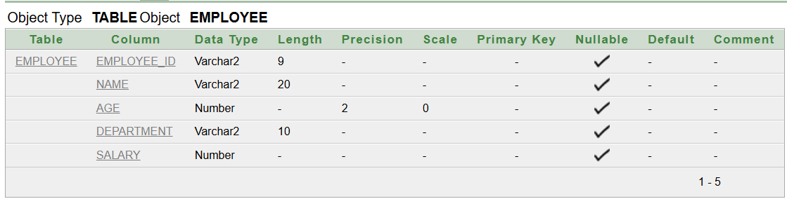

Figure 4.2: Describing EMPLOYEE Table

Task No. 2: Adding a column of Salary for employees
ADD QUERY:-
ALTER TABLE EMPLOYEE_NEW
ADD SALARY NUMBER
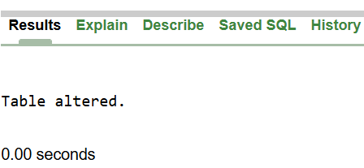

Figure 4.3: EMPLOYEE Table Altered

DESCRIBE QUERY:-

DESCRIBE EMPLOYEE

Figure 4.4: Describing EMPLOYEE Table after alteration

Task No. 3: Renaming the table from "Employees" to "EmployeeDetails."
RENAME QUERY:-
RENAME "EMPLOYEE" TO "EMPLOYEE_DETAILS"
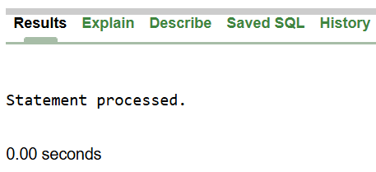

Figure 4.5: Table Renamed

Task No. 4: Inserting a new employee record into the table
INSERT QUERY:-
INTO EMPLOYEE_DETAILS VALUES ('2', 'M. HASHIR AFZAAL', 20, 'IT', 45)
INTO EMPLOYEE_DETAILS VALUES ('234', 'M. HASHIR', 22, 'IT', 45)
INTO EMPLOYEE_DETAILS VALUES ('235', 'M. AFZAAL', 23, 'IT', 45)
INTO EMPLOYEE_DETAILS VALUES ('345', 'MUHAMMAD', 29, 'IT', 45)
INTO EMPLOYEE_DETAILS VALUES ('25', 'M. FAISAL', 27, 'IT', 45)
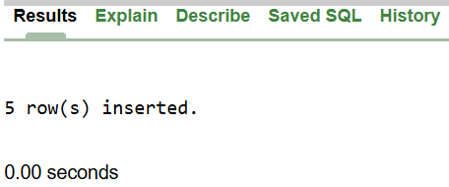
SELECT * FROM DUAL;

Figure 4.6: Values Inserted

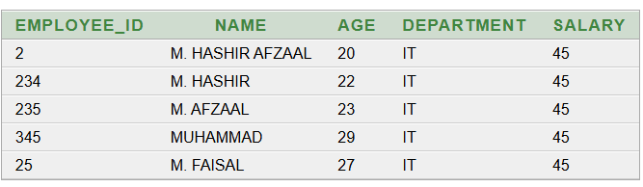

Figure 4.7: Table with inserted values

Task No. 5: Updating an employee's department from IT to HR
UPDATE QUERY:-
UPDATE EMPLOYEE_DETAILS SET DEPARTMENT='HR' WHERE DEPARTMENT='IT'
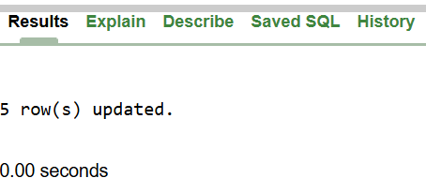
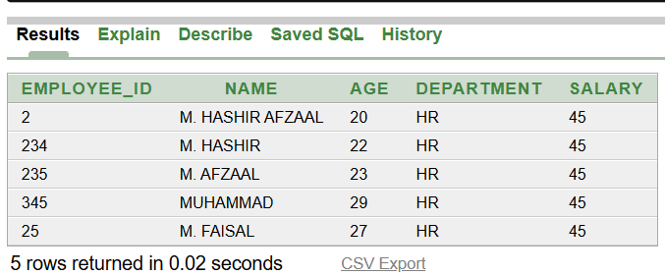
Figure 4.9: Table with new values
Figure 4.8: Table Updated

Task No. 6: Deleting an employee's record from the database.
DELETE QUERY:-
DELETE FROM EMPLOYEE_DETAILS
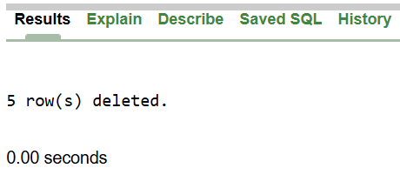
Figure 4.10: Deleted Table Record

Scenario No. 2: Managing a Library System
Task No. 1: Creating a table for books
CREATE QUERY
CREATE TABLE BOOKS(
BOOK_ID NUMBER,
TITLE VARCHAR2(20),
AUTHOR VARCHAR2(20),
PUBLISHED_YEAR DATE);
DESCRIBE QUERY:-
DESCRIBE BOOKS


Figure 4.11: BOOKS Table Created
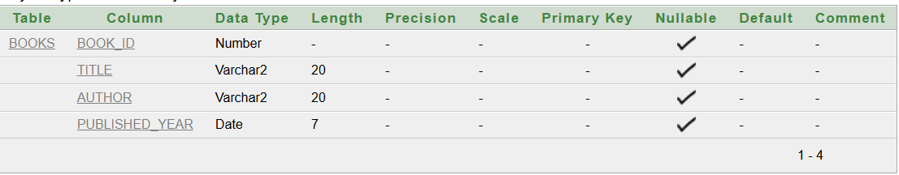

Figure 4.12: Describing BOOKS Table

Task No. 2: Adding a column of Salary for employees
ADD QUERY:-
ALTER TABLE EMPLOYEE_NEW
ADD GENRE


Figure 4.13: BOOKS Table Altered
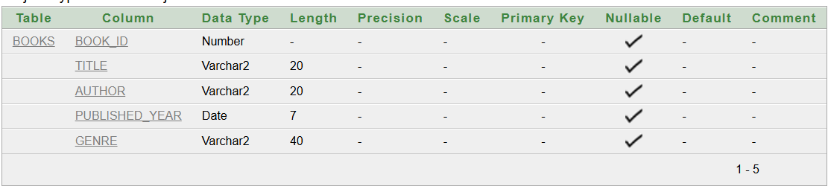

Figure 4.14: Describing BOOKS Table after alteration

Task No. 3: Renaming the table from "Books" to "LibraryBooks."
RENAME QUERY:-
RENAME "BOOKS" TO "LIBRARY_BOOKS"


Figure 4.15: Table Renamed

Task No. 4: Inserting a new book record into the table
INSERT QUERY:-
INSERT ALL
INTO LIBRARY_BOOKS VALUES(102, 'ABC', 'FAISAL', TO_DATE('23-12-2004','DD-MM-YYYY'), 'HISTORY')
INTO LIBRARY_BOOKS VALUES(108, 'ABCF', 'FA', TO_DATE('29-12-2004','DD-MM-YYYY'), 'ENG')
INTO LIBRARY_BOOKS VALUES(106, 'ABS', 'FK', TO_DATE('28-12-2004','DD-MM-YYYY'), 'PHY')
INTO LIBRARY_BOOKS VALUES(105, 'ADA', 'MFK', TO_DATE('25-12-2004','DD-MM-YYYY'), 'CHEM')
INTO LIBRARY_BOOKS VALUES(10, 'SDF', 'FAI', TO_DATE('24-12-2004','DD-MM-YYYY'), 'ISL')
SELECT * FROM DUAL;


Figure 4.16: Values Inserted

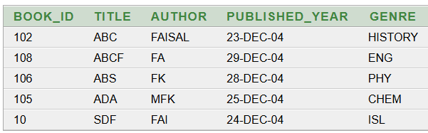

Figure 4.17: Table with inserted values

Task No. 5: Updating the book's genre to "Classic Fiction."
UPDATE QUERY:-
UPDATE LIBRARY_BOOKS SET GENRE='CLASSIC_FICTION'

Figure 4.18: Table Updated

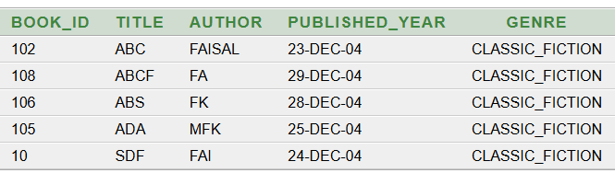

Figure 4.19: Table with new values

Task No. 6: Removing a book record from the database when it is no longer available
DELETE QUERY:-
DELETE FROM LIBRARY_BOOKS

Figure 4.20: Deleted Table Record

Scenario No. 3: Managing an Online Store's Product Inventory
Task No. 1: Creating a table for products
CREATE QUERY
CREATE TABLE PRODUCT(
PRODUCT_ID NUMBER PRIMARY KEY,
PRODUCT_NAME VARCHAR2(20) NOT NULL,
PRICE NUMBER UNIQUE,
STOCK CHAR(1));
DESCRIBE QUERY:-
DESCRIBE PRODUCTS


Figure 4.21: PRODUCT Table Created
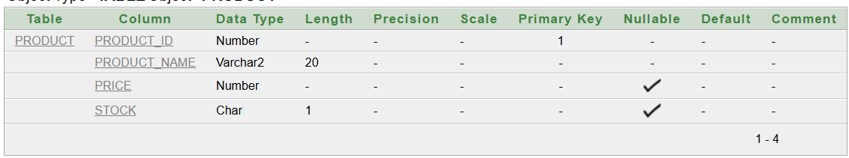

Figure 4.22: Describing PRODUCT Table

Task No. 2: Adding a column of SUPPLIER for products
ADD QUERY:-
ALTER TABLE PRODUCT

ADD SUPPLIER VARCHAR2(20)

Figure 4.23: PRODUCT Table Altered
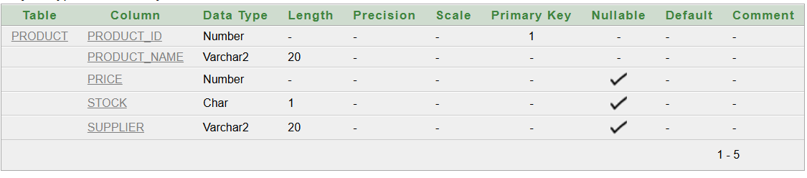
Figure 4.24: Describing PRODUCT Table after alteration

Task No. 3: Renaming the table from "PRODUCT" to "STOREPRODUCTS"
RENAME QUERY:-
RENAME " PRODUCT " TO " STOREPRODUCTS”


Figure 4.25: Table Renamed

Task No. 4: Inserting a new product record into the table
INSERT QUERY:-
INSERT ALL
INTO STORE_PRODUCTS VALUES (1, 'MOBILE', 1200, 'Y', 'TECH')
INTO STORE_PRODUCTS VALUES (2, 'CAMERA', 25, 'N', 'TECH')
INTO STORE_PRODUCTS VALUES (3, 'MOUSE', 45, 'Y', 'TECH')
INTO STORE_PRODUCTS VALUES (4, 'KEYBOARD', 200, 'Y', 'TECH')
INTO STORE_PRODUCTS VALUES (5, 'CASE', 150, 'N', 'TECH')
SELECT * FROM DUAL;


Figure 4.26: Values Inserted

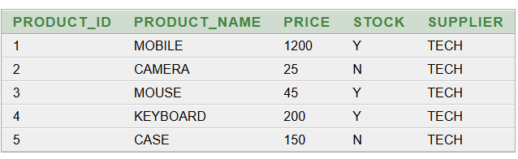

Figure 4.27: Table with inserted values

Task No. 5: Updating the price of a product to reflect a new discount.
UPDATE QUERY:-
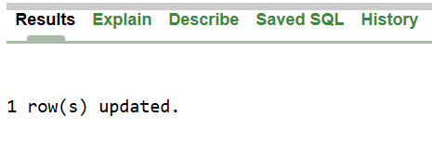
UPDATE STORE_PRODUCTS SET PRICE='100' WHERE PRODUCT_NAME = 'KEYBOARD'
Figure 4.18: Table Updated

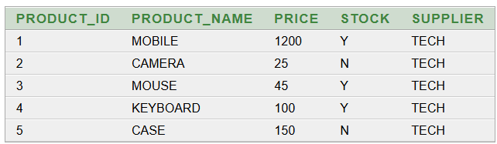

Figure 4.19: Table with new values

Task No. 6: Deleting a product record when it is out of stock or discontinued
DELETE QUERY:-
DELETE FROM STORE_PRODUCTS

Figure 4.20: Deleted Table Record

Scenario No. 4: Managing a Hospital's Patient Records
Task No. 1: Creating a table for patients
CREATE QUERY
CREATE TABLE PATIENTS (
PATIENT_ID NUMBER PRIMARY KEY,
PATIENT_NAME VARCHAR2(20),
PATIENT_AGE NUMBER NOT NULL,
PATIENT_DISEASE VARCHAR2(50) );
DESCRIBE QUERY:-
DESCRIBE PATIENTS


Figure 4.31: PRODUCT Table Created
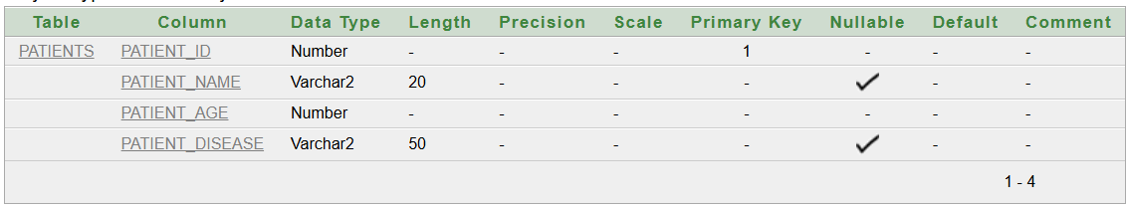

Figure 4.32: Describing PATIENTS Table

Task No. 2: Adding a column for Doctor Name
ADD QUERY:-
ALTER TABLE PRODUCT

ADD SUPPLIER VARCHAR2(20)

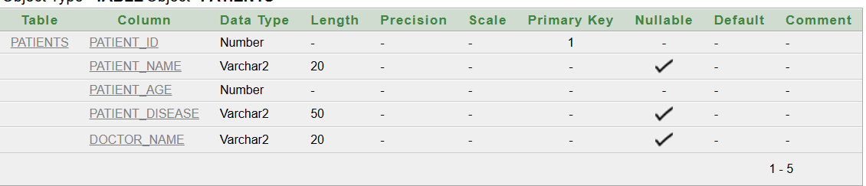
Figure 4.33: PRODUCT Table Altered

Figure 4.34: Describing PRODUCT Table after alteration

Task No. 3: Renaming the table from "Patients" to "PatientRecords."
RENAME QUERY:-
RENAME " PATIENTS " TO "PATIENT_RECORDS”


Figure 4.35: Table Renamed

Task No. 4: Inserting a new product record into the table
INSERT QUERY:-
INSERT ALL
INTO PATIENT_RECORDS VALUES (1, 'FAISAL', 45, 'Diabetes', 'DR.KAMRAN')
INTO PATIENT_RECORDS VALUES (2, 'HARIS', 30, 'Hypertension', 'DR.AWAN')
INTO PATIENT_RECORDS VALUES (3, 'HASHIR', 55, 'Asthma', 'DR.AFZAAL')
INTO PATIENT_RECORDS VALUES (4, 'MALIK', 40, 'Arthritis', 'DR.KHALID')
INTO PATIENT_RECORDS VALUES (5, 'HASEEB', 60, 'Heart Disease', 'DR.ARIF')
SELECT * FROM DUAL;

Figure 4.36: Values Inserted

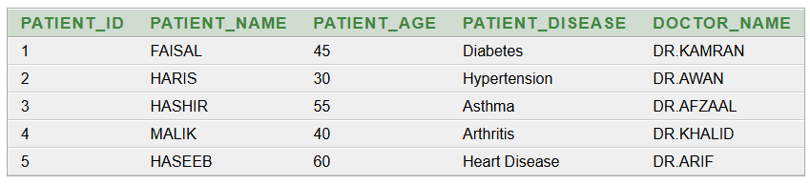

Figure 4.37: Table with inserted values

Task No. 5: Updating the price of a product to reflect a new discount.
UPDATE QUERY:-
UPDATE PATIENT_RECORDS SET DOCTOR_NAME='DR.AKRAM' WHERE DOCTOR_NAME = 'DR.KAMRAN'


Figure 4.38: Table Updated
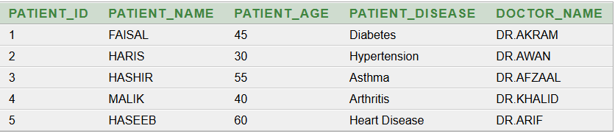

Figure 4.9: Table with new values

Task No. 6: Deleting a patient record when treatment is completed or the record is no longer needed.
DELETE QUERY:-
DELETE FROM PATIENT_RECORDS WHERE PATIENT_ID = 1
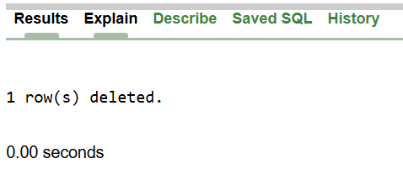

Figure 4.30: Deleted Table Record
Task No. 7 Deleting the table when patient records are no longer required.
DELETE QUERY:-
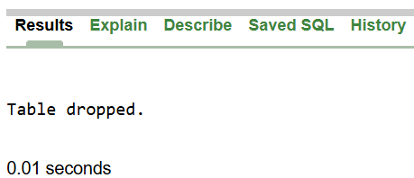
DROP TABLE PATIENT_RECORDS;

Figure 4.31: Deleted Table Record

Lab No 5 and 6: WHERE and ORDER BY Clause and Other Restricting Data Constraints
Task No. 1: Using WHERE Clause
Simple WHERE Clause
SELECT QUERY:-
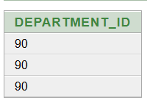
SELECT DEPARTMENT_ID FROM EMPLOYEES WHERE DEPARTMENT_ID=90

Figure 5.1: Values where DEPARTMENT_ID = 90

WHERE Using String
SELECT QUERY
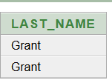
SELECT LAST_NAME FROM EMPLOYEES WHERE LAST_NAME='Grant'

Figure 5.2: Values where LAST_NAME = Grant

WHERE Using GREATER THAN Condition
SELECT QUERY
SELECT EMPLOYEE_ID FROM EMPLOYEES WHERE SALARY>20000
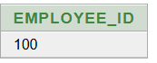
Figure 5.3: Values where Employees SALARY > 20000

WHERE Using BETWEEN CONDTION
SELECT QUERY:-
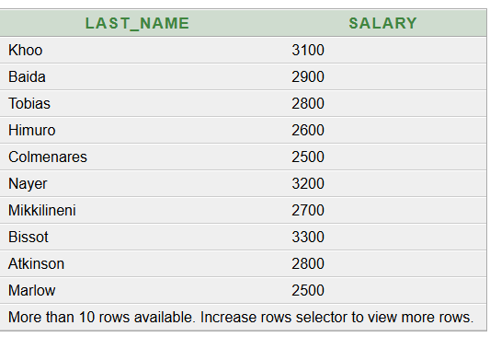
SELECT LAST_NAME,SALARY FROM EMPLOYEES WHERE SALARY BETWEEN 2500 AND 3500

Figure 5.4: Values where Employees Between 2500 And 3500

WHERE Using IN CONDTION
SELECT QUERY:-
SELECT EMPLOYEE_ID,LAST_NAME,SALARY,MANAGER_ID FROM EMPLOYEES WHERE MANAGER_ID IN(100,101,102)
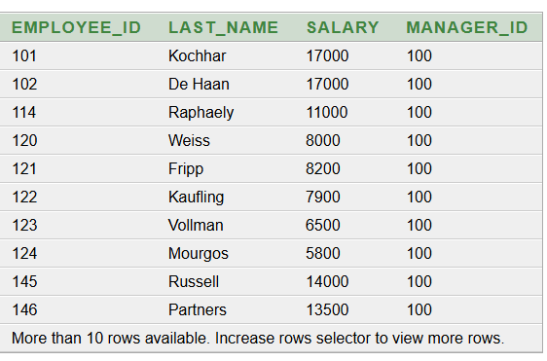
Figure 5.5: Values where MANAGER_ID is 100,101 or 102

WHERE Using IN Condition:-
SELECT QUERY:-
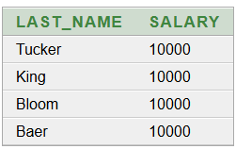
SELECT LAST_NAME,SALARY FRO M EMPLOYEES WHERE SALARY IN (10000,20000)

Figure 5.6: Values where MANAGER_ID is 10000 or 20000

WHERE Using LIKE Condition:-
SELECT QUERY Using LIKE Condition:-
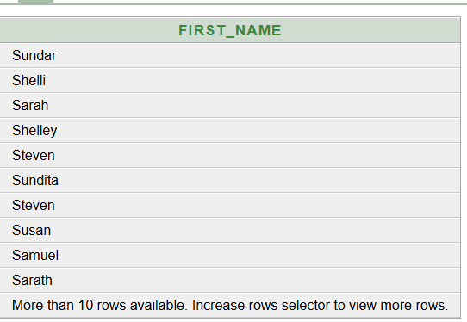
SELECT FIRST_NAME FROM EMPLOYEES WHERE FIRST_NAME LIKE 'S%'
Figure 5.7: Values where FIRST_NAME Starts with S

WHERE Using LIKE Condition:-
SELECT QUERY:-
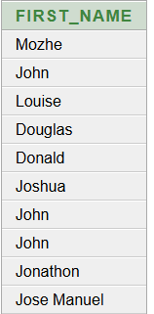
SELECT FIRST_NAME FROM EMPLOYEES WHERE FIRST_NAME LIKE '_o%'

Figure 5.8: Values where FIRST_NAME Second letter is O
WHERE Using IS NULL Condition:-
SELECT QUERY:-
SELECT LAST_NAME,MANAGER_ID FROM EMPLOYEES WHERE MANAGER_ID IS NULL
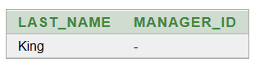

Figure 5.9: Values where MANAGER_ID Is Null

WHERE Using IS NULL Condition:-
SELECT QUERY:-
SELECT LAST_NAME,COMMISSION_PCT FROM EMPLOYEES WHERE COMMISSION_PCT IS NULL
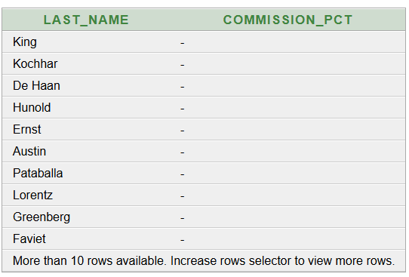
Fig 5.7: Values where MANAGER_ID Is Null

Figure 5.10: Values where PCT_COMMISSION Is Null

WHERE Using AND Condition:-
SELECT QUERY:-
SELECT EMPLOYEE_ID,SALARY,JOB_ID,LAST_NAME FROM EMPLOYEES WHERE SALARY>=10000 AND JOB_ID LIKE ('%MAN%')
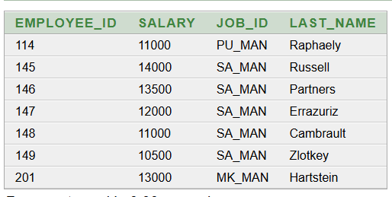

Figure 5.11: Values where SALARY>=10000 And JOB_ID Has MAN

WHERE Using NOT Condition:-
SELECT QUERY:-
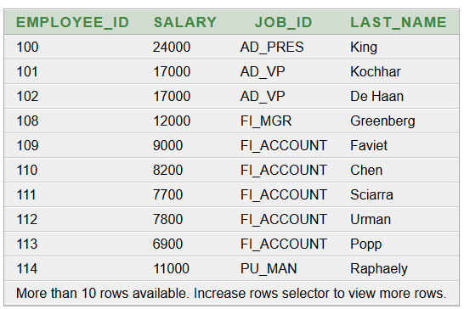
SELECT EMPLOYEE_ID,SALARY,JOB_ID,LAST_NAME FROM EMPLOYEES WHERE JOB_ID NOT IN ('IT_PROG','ST_CLERK','ST_REP')

Figure 5.12: Values where JOB_ID Is NOT IN 'IT_PROG','ST_CLERK','ST_REP'

WHERE Using OR Condition:-
SELECT QUERY:-
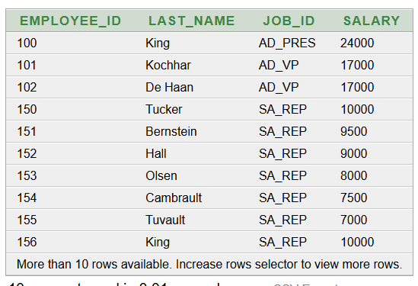
SELECT EMPLOYEE_ID,LAST_NAME,JOB_ID,SALARY FROM EMPLOYEES WHERE JOB_ID= 'SA_REP'OR SALARY>15000;

Figure 5.13: Values where SALARY>15000 OR JOB_ID Is SA_REP'OR SALARY

WHERE Using OR with AND Condition:-
SELECT QUERY:-
SELECT EMPLOYEE_ID,LAST_NAME,JOB_ID,SALARY FROM EMPLOYEES WHERE (JOB_ID= 'SA_REP'OR JOB_ID = 'AD_PRES') AND SALARY>15000;
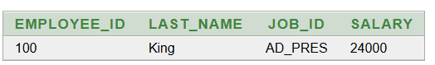

Figure 5.14: Values where SALARY>15000 AND JOB_ID Is SA_REP'OR SALARY OR AD_PRES

Task No. 2: Using ORDER BY Clause
Simple ORDER BY Clause
SELECT QUERY:-
SELECT LAST_NAME,JOB_ID,SALARY, HIRE_DATE FROM EMPLOYEES ORDER BY HIRE_DATE ;
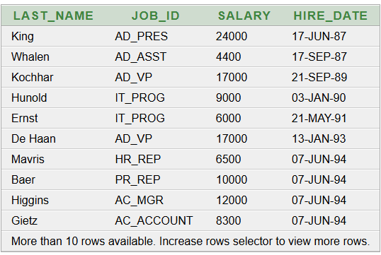

Figure 5.15: Values Ordered By HIRE_DATE

ORDER BY Clause With Ascending Order
SELECT QUERY:-
SELECT LAST_NAME,JOB_ID,SALARY FROM EMPLOYEES ORDER BY SALARY ASC;
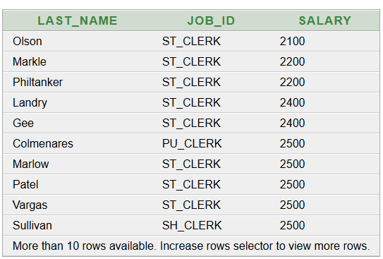

Figure 5.16: SALARY In Ascending Order
ORDER BY Clause With Ascending Order
SELECT QUERY:-
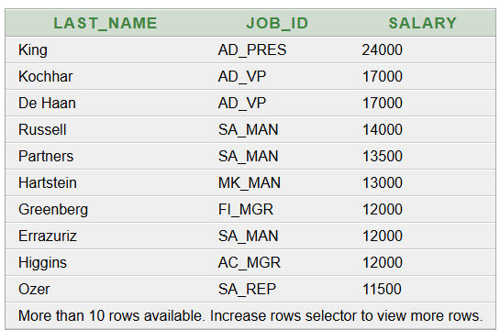
SELECT LAST_NAME,JOB_ID,SALARY FROM EMPLOYEES ORDER BY SALARY DESC;

Figure 5.17: SALARY In Descending Order

Lab No 7: Practical Test
Question No 1: Monthly Sales Table
Task No. 1: Create Table using CREATE Command
ÇREATE QUERY:-
CREATE TABLE MONTHLY_SALES (
CUST_ID NUMBER,
PROD_ID NUMBER,
PROD_NAME VARCHAR2(50),
PRICE NUMBER,
QUANTITY NUMBER,
BILL_TOTAL NUMBER,
DOB DATE

);
Figure 7.1: Table Created

DESCRIBE QUERY:-
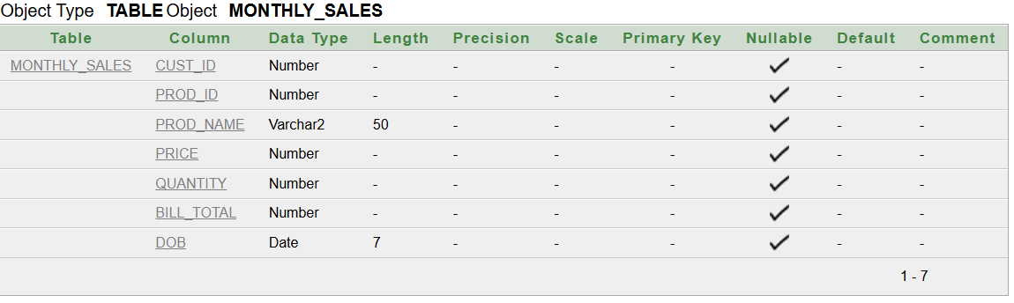
DESCRIBE MONTHLY_SALES
Figure 7.2: MONTHLY_SALES Table

Task No. 2: Inserting Values using INSERT Command
INSERT QUERY:-
INSERT ALL
INTO MONTHLY_SALES VALUES (1, 1, 'Shampoo', 165, 2, 330, TO_DATE('26-MAR-23', 'DD-MON-RR'))
INTO MONTHLY_SALES VALUES (2, 2, 'Soap', 32, 10, 320, TO_DATE('26-MAR-23', 'DD-MON-RR'))
INTO MONTHLY_SALES VALUES (3, 3, 'Cream', 85, 1, 85, TO_DATE('26-MAR-23', 'DD-MON-RR'))
INTO MONTHLY_SALES VALUES (4, 1, 'Shampoo', 165, 1, 165, TO_DATE('27-MAR-23', 'DD-MON-RR'))
INTO MONTHLY_SALES VALUES (5, 3, 'Cream', 85, 2, 170, TO_DATE('28-MAR-23', 'DD-MON-RR'))
SELECT * FROM DUAL;
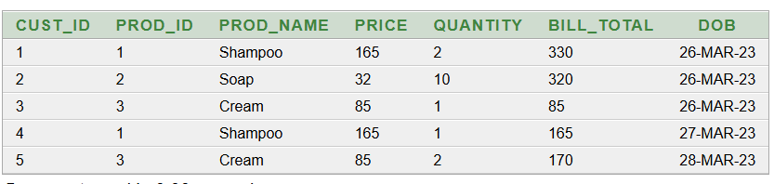
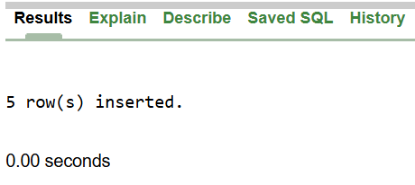
Figure 7.4: MONTHLY_SALES Table with inserted values
Figure 7.3: Values Inserted

Task No. 3: Add Column using ALTER Command
ALTER QUERY:-
ALTER TABLE MONTHLY_SALES
ADD Return_Date DATE;
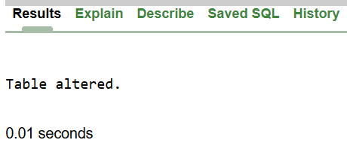
Figure 7.5: Table Altered

DESCRIBE QUERY:-
DESCRIBE MONTHLY_SALES
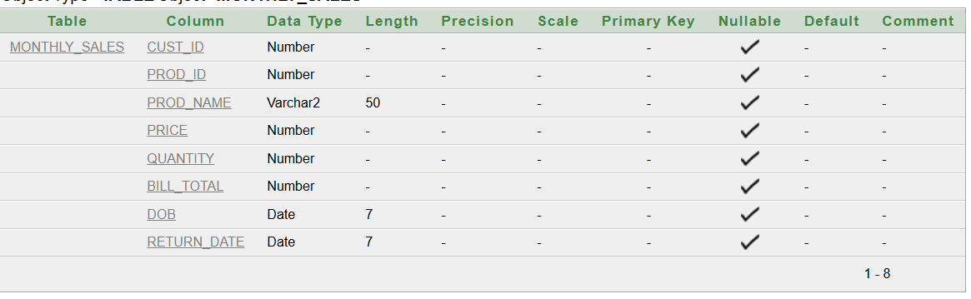
Figure 7.6: Altered MONTHLY_SALES Table

Task No. 4: Rename Column using ALTER Command
ALTER QUERY:-
ALTER TABLE MONTHLY_SALES
RENAME COLUMN DOB TO Sales_Date;

Figure 7.7: Table Altered

DESCRIBE QUERY:-
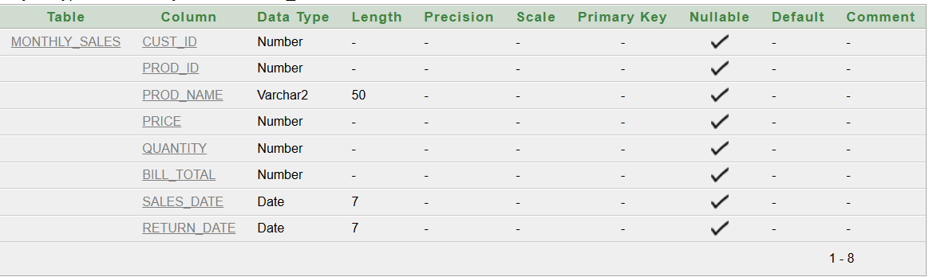
DESCRIBE MONTHLY_SALES
Figure 7.8: Table Updated

Task No. 5: Drop Column using ALTER Command
ALTER QUERY:-
ALTER TABLE MONTHLY_SALES
DROP COLUMN RETURN_DATE


Figure 7.7: Table Altered

DESCRIBE QUERY:-
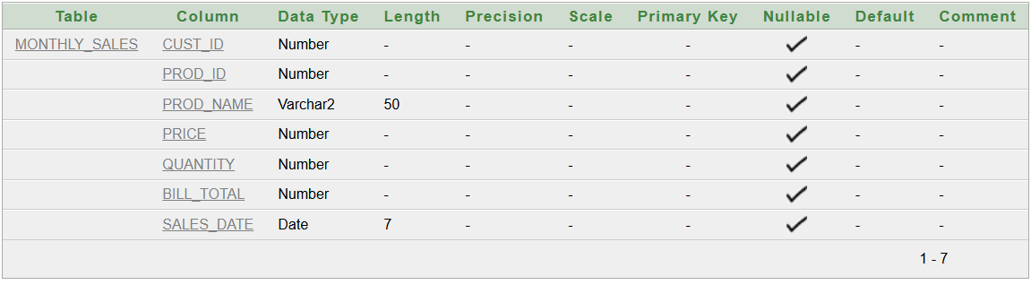
DESCRIBE MONTHLY_SALES
Figure 7.9: Table Updated

Task No. 6: Update Column using UPDATE Command
UPDATE QUERY:-
UPDATE MONTHLY_SALES
SET Price = 100
WHERE PROD_ID = 3;
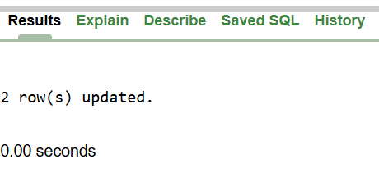

Figure 7.10: Rows Updated

SELECT QUERY:-
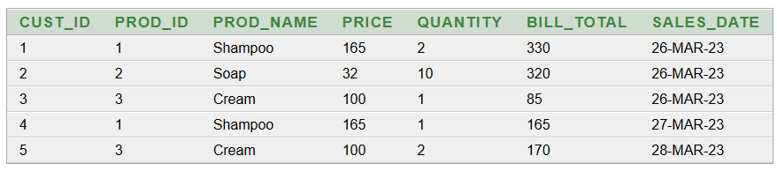
SELECT* FROM MONTHLY_SALES
Figure 7.11: Table After Update

Question No 2: STUDENT Table
Task No. 1: Create Table using CREATE Command
ÇREATE QUERY:-
CREATE TABLE STUDENT (
Name VARCHAR2(50),
Address VARCHAR2(100),
Class VARCHAR2(20),
CGPA NUMBER(3,2)

);

Figure 7.12: Table Created

DESCRIBE QUERY:-
DESCRIBE STUDENT
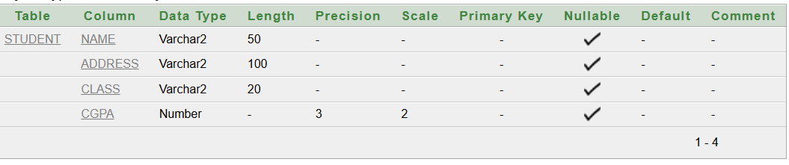

Figure 7.13: Table Described

Task No. 2: Insert Values using INSERT Command
INSERT QUERY:-
INSERT ALL
INTO STUDENT VALUES ('Bilal', 'Islamabad', 'BSCS', 3.65)
INTO STUDENT VALUES ('Faisal', 'Bahawalnagar', 'BSIT', 3.45)
INTO STUDENT VALUES ('Aqsa', 'Lahore', 'BSCS', 3.70)
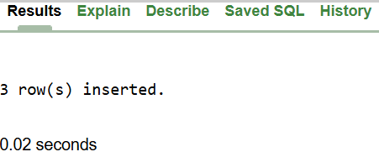
SELECT * FROM DUAL;
Figure 7.14: Values Inserted

SELECT QUERY:-
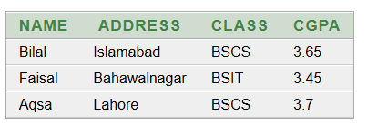
SELECT* FROM STUDENT
Figure 7.15: Table with inserted values

Task No. 3:Selecting Values using SELECT Command
SELECT QUERY:-
SELECT Name, CGPA
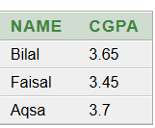
FROM STUDENT;
Figure 7.16: Display NAME and CGPA From Table

SELECT QUERY:-
SELECT Name
FROM STUDENT
WHERE CGPA > 3.5;
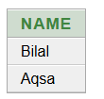
Figure 7.17: Display NAME where CGPA is greater than 3.5Q

Lab No 8: Introduction to MYSQL Using GUI

Task : Creating new database and table in it
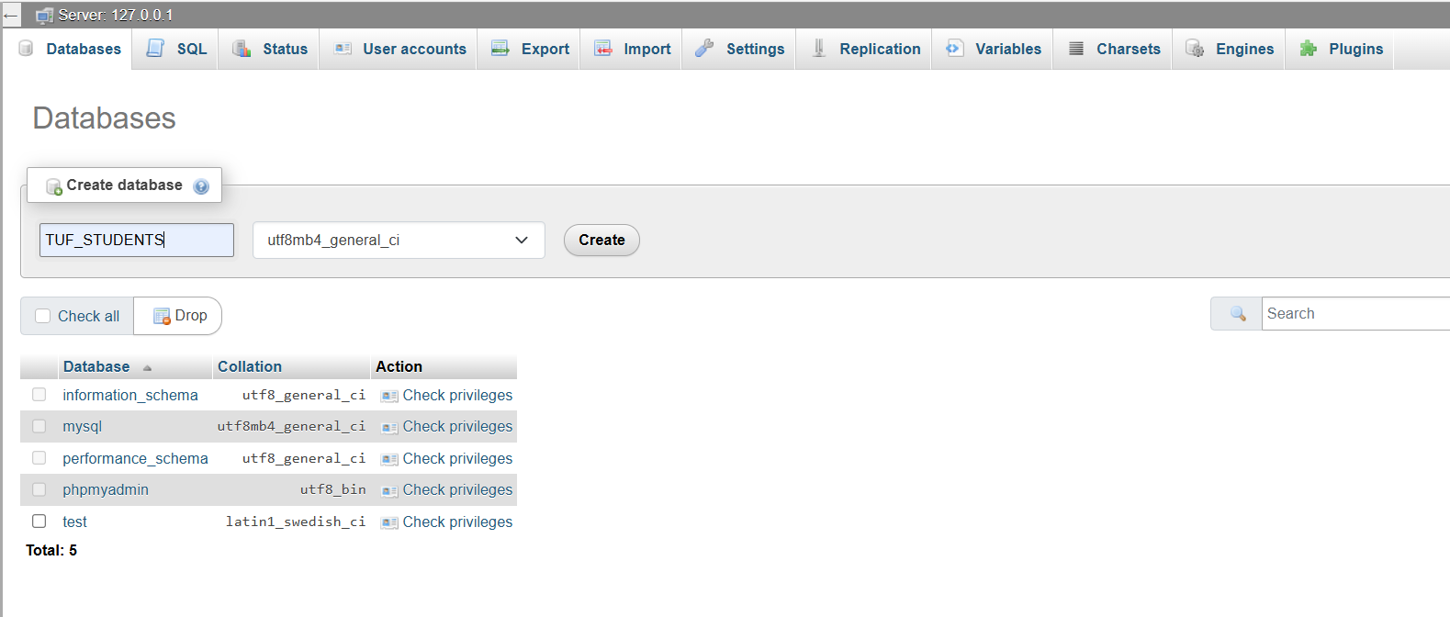
Figure 8.1: Creating Database

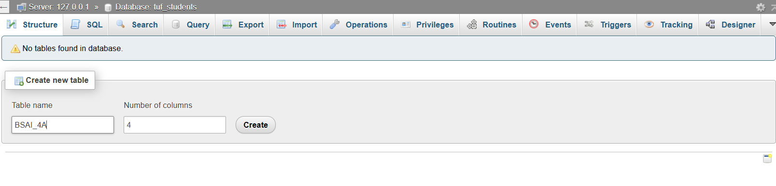

Figure 8.2: Set Table Name

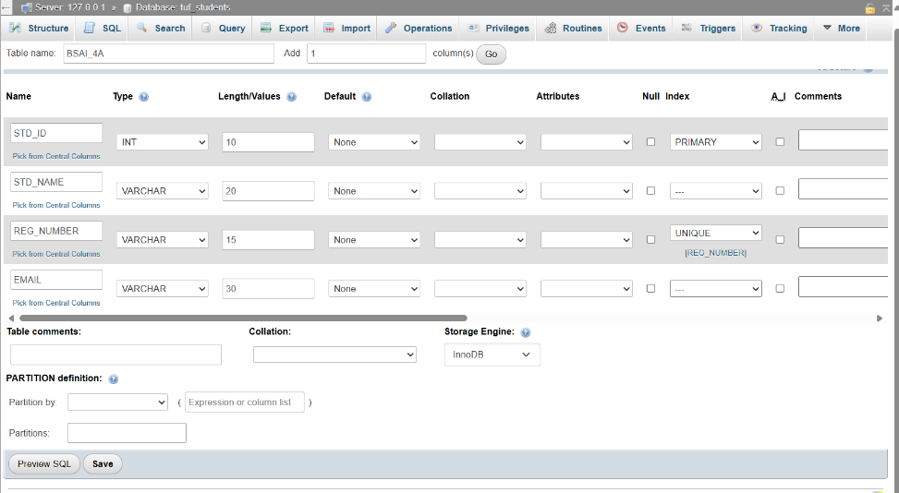

Figure 8.3: Creating Columns
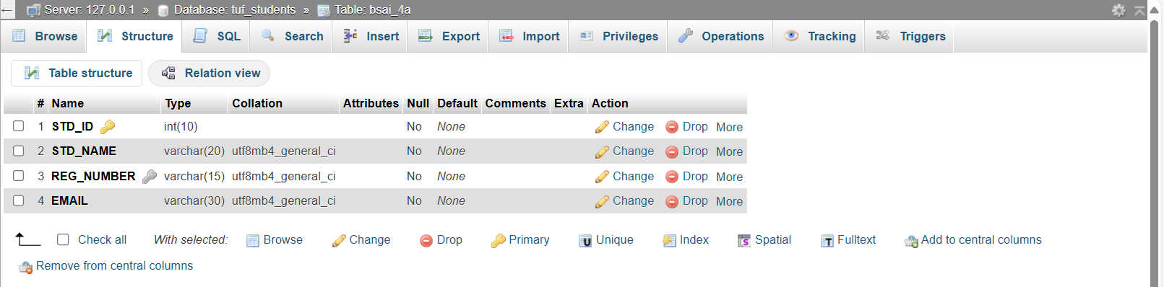

Figure 8.4: STD_ID is Primary Key and REG_NUMBER is UNIQUE

Lab No 9: Create Table in MYSQL using DDL Commands
Task 1: Create Table IT_FACULTY
CREATE QUERY:-
CREATE TABLE IT_FACULTY(
ID INT PRIMARY KEY,
NAME VARCHAR(40),
DEPARTMENT VARCHAR(40),
EMAIL VARCHAR(40)
);
DESCRIBE QUERY:-
DESCRIBE IT_FACULTY
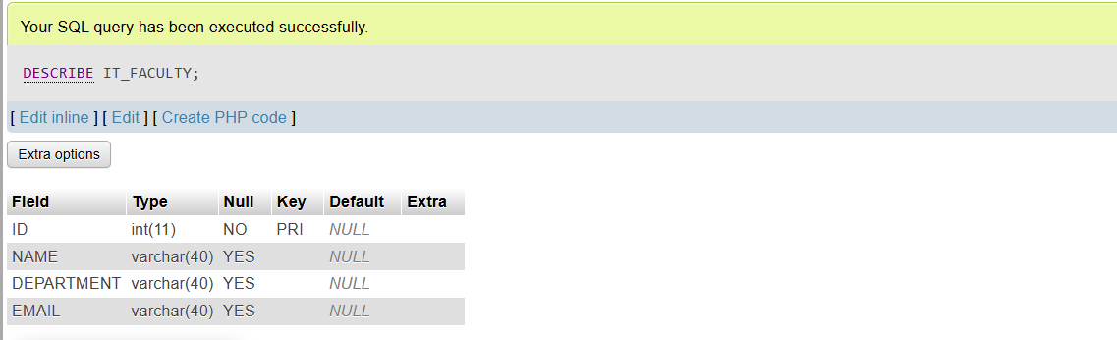
Figure 9.1: IT_FACULTY Table Created

Task 2: Create Table STD_BSAI
CREATE QUERY:-
CREATE TABLE STD_BSAI(
REG_NO VARCHAR(50),
STD_NAME VARCHAR(40),
DOB DATE,
STD_PHONE VARCHAR(10),
STD_ADDRESS VARCHAR(70),
FACULTY_ID INT,
FOREIGN KEY (FACULTY_ID)
REFERENCES IT_FACULTY(ID)
);
DISPLAY QUERY:-
DESCRIBE STD_BSAI
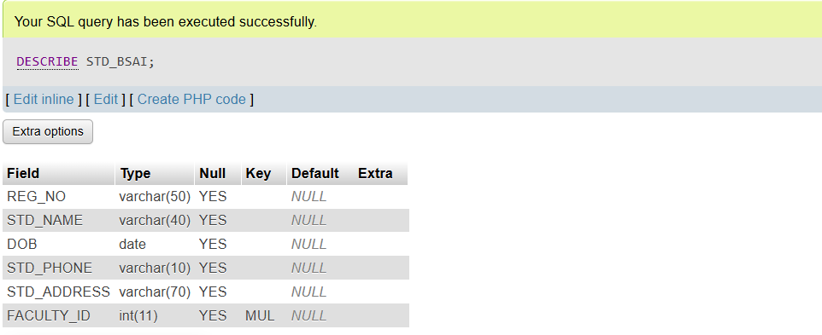
Figure 9.2: STD_BSAI Table Created

Task 3: Add column EMAIL to Table
ALTER QUERY:-
ALTER TABLE STD_BSAI
ADD EMAIL VARCHAR(40)
DESCRIBE QUERY:-
DESCRIBE STD_BSAI
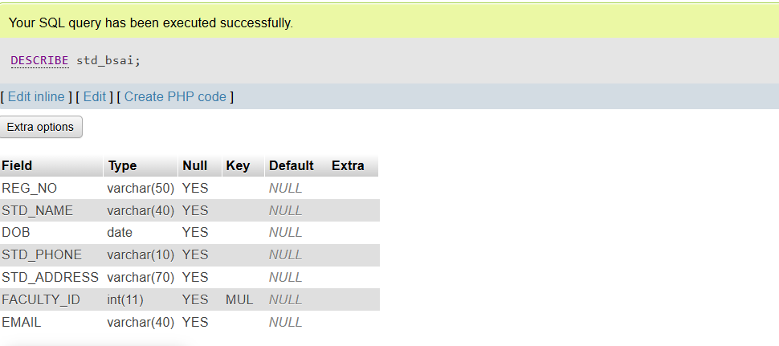
Figure 9.3: Column Added

Task 4: Modify Table
ALTER QUERY:-
ALTER TABLE STD_BSAI
MODIFY EMAIL CHAR(40)
DESCRIBE QUERY:-
DESCRIBE STD_BSAI
SELECT QUERY:-
SELECT* FROM STD_BSAI

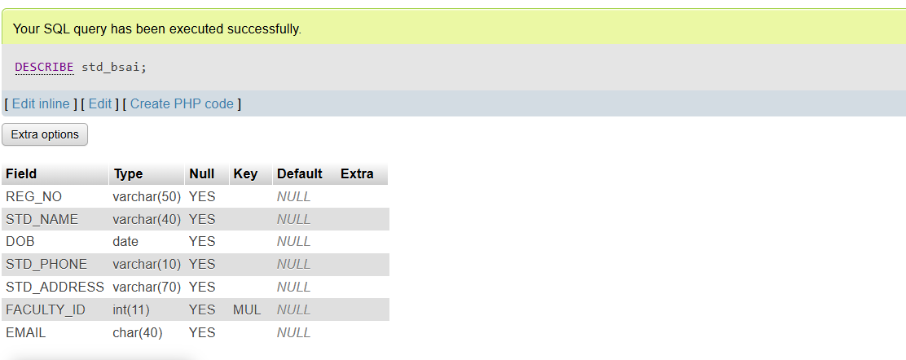

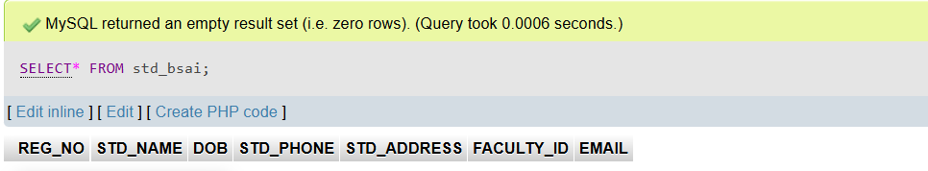
Figure 9.4: Table Modified

Lab No 10: Create Table And Inserting Values in MYSQL using DML Commands
Question 1: Create Table MONTHLY_SALES
Task No. 1: Create Table using CREATE Command
ÇREATE QUERY:-
CREATE TABLE MONTHLY_SALES (
PROD_ID INT PRIMARY KEY,
PROD_NAME VARCHAR(50) NOT NULL,
PRICE INT UNIQUE,
QUANTITY INT,
BILL_TOTAL INT,
DOB DATE
);
DESCRIBE QUERY:-
DESCRIBE MONTHLY_SALES

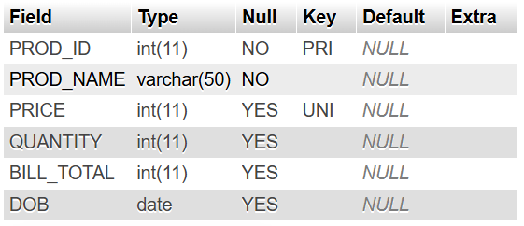

Figure 10.1: Table Created

Task No. 2: Insert Values Using INSERT Command
INSERT QUERY:-
INSERT INTO MONTHLY_SALES
VALUES
(1, 'Shampoo', 165, 2, 330, '2023-03-26'),
(2, 'Soap', 32, 10, 320, '2023-03-26'),
(3, 'Cream', 85, 1, 85, '2023-03-26'),
(4, 'Shampoo', 170, 1, 165, '2023-03-27'),
(5, 'Cream', 90, 2, 170, '2023-03-28');
SELECT QUERY:-
SELECT* FROM MONTHLY_SALES
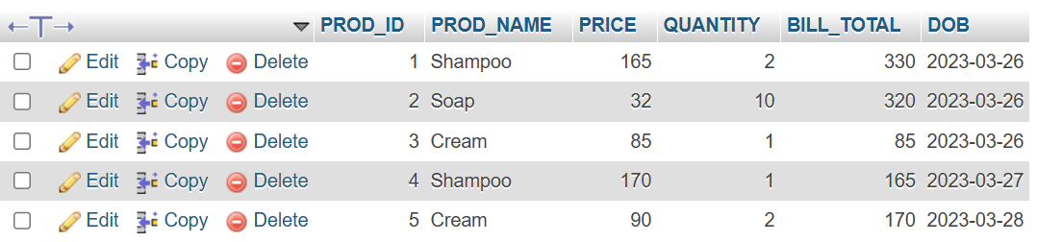

Figure 10.2: Values Inserted

Task No. 3: Add Column Using ALTER Command
ALTER QUERY:-
ALTER TABLE MONTHLY_SALES
ADD COLUMN Return_Date DATE;
DESCRIBE QUERY:-
DESCRIBE MONTHLY_SALES
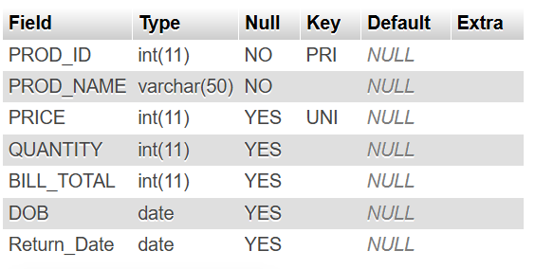

Figure 10.3: Column Added

Task No. 4: Rename Column Using ALTER Command
ALTER QUERY:-
ALTER TABLE MONTHLY_SALES
CHANGE COLUMN DOB Sales_Date DATE;
DESCRIBE QUERY:-
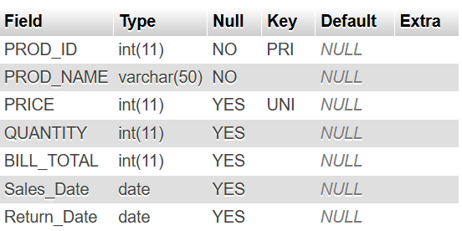
DESCRIBE MONTHLY_SALES

Figure 10.4: Column Renamed
Task No. 5: Drop Column Using ALTER Command
ALTER QUERY:-
ALTER TABLE MONTHLY_SALES
DROP COLUMN Return_Date;
DESCRIBE QUERY:-
DESCRIBE MONTHLY_SALES
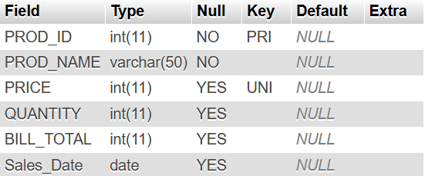

Figure 10.5: Column Dropped

Task No. 6: Update Column Using UPDATE Command
UPDATE QUERY:-
UPDATE MONTHLY_SALES
SET Price = 100
WHERE PROD_ID = 3;
SELECT QUERY:-
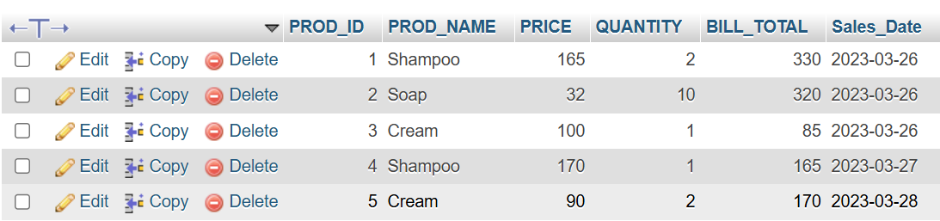
SELECT* FROM MONTHLY_SALES
Figure 10.6: Column Dropped

Question 2: Create Table STUDENT
Task No. 1: Create Table using CREATE Command
ÇREATE QUERY:-
CREATE TABLE STUDENT (
Name VARCHAR(50),
Address VARCHAR(100),
Class VARCHAR(10),
CGPA DECIMAL(3,2)
);
DESCRIBE QUERY:-
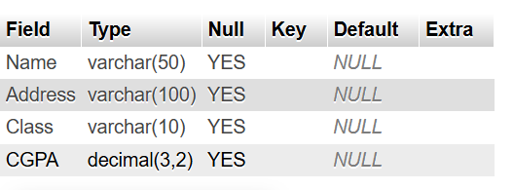
DESCRIBE STUDENT
Figure 10.7: Table Created

Task No. 2: Insert Values Using INSERT Command
INSERT QUERY:-
INSERT INTO STUDENT
VALUES
('Bilal', 'Islamabad', 'BSCS', 3.65),
('Faisal', 'Bahawalnagar', 'BSIT', 3.45),
('Aqsa', 'Lahore', 'BSCS', 3.70);
SELECT QUERY:-
SELECT* FROM STUDENT
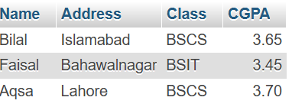
Figure 10.8: Values Inserted

Task No. 3: Display student names and CGPA only
SELECT QUERY:-
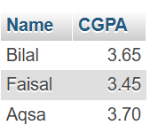
SELECT Name, CGPA FROM STUDENT;

Figure 10.9: Name and CGPA Displayed

Task No. 4: Display all student names that have more than a 3.5 CGPA
SELECT QUERY:-
SELECT Name FROM STUDENT WHERE CGPA > 3.5;
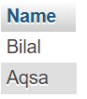
Figure 10.9: Name with more than 3.5 CGPA Displayed

rgnhrggt
Scenario 1: Online Food Delivery
Q.1: Create a database called FoodDeliveryDB and select it for use.
QUERY:-
CREATE DATABASE FoodDeliveryDB;
USE FoodDeliveryDB;
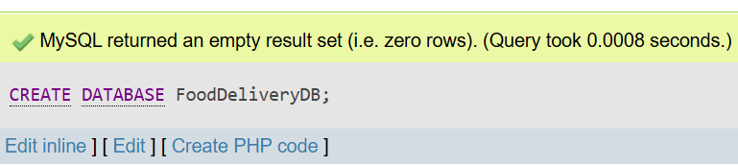

Figure 11.1 : Database Created

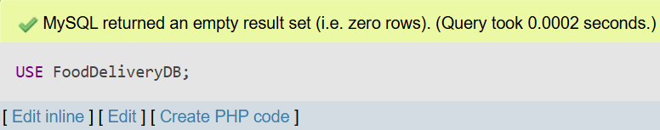

Figure 11.2 : Using Database

Q.2: Create a table named Orders with fields for order ID, customer name, food item, quantity, order date, and delivery status.
- OrderID is the primary key.
- Quantity must be greater than 0 (using a CHECK constraint).
- DeliveryStatus will default to 'Pending' if not specified.
QUERY:-
CREATE TABLE Orders (
OrderID INT PRIMARY KEY,
CustomerName VARCHAR(100),
FoodItem VARCHAR(100),
Quantity INT CHECK (Quantity > 0),
OrderDate DATE,
DeliveryStatus VARCHAR(20) DEFAULT 'Pending'
);
DESCRIBE ORDERS;
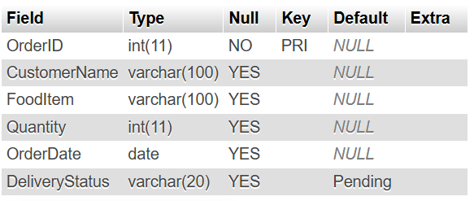

Figure 11.3 : Table Created

Q.3: Show all databases and show tables inside FoodDeliveryDB.
QUERY:-
SHOW DATABASES;
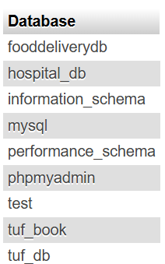
SHOW TABLES FROM FoodDeliveryDB;
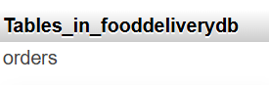

Figure 11.4 : Databases and Tables

Q.4: Add a new column called TotalPrice to the Orders table.
QUERY:-
ALTER TABLE Orders
ADD COLUMN TotalPrice INT;
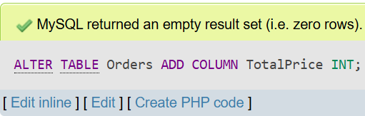

Figure 11.5 : Column Added
Q.5: Insert ten food order records into the table.
QUERY:-
INSERT INTO Orders (OrderID, CustomerName, FoodItem, Quantity, OrderDate, TotalPrice)
VALUES
(101, 'Faisal', 'Wrap', 2, '2025-05-01', 600),
(102, 'Hashir', 'Tacos', 1, '2025-05-02', 900),
(103, 'Hateem', 'Nuggets', 3, '2025-05-03', 450),
(104, 'Haris', 'Steak', 4, '2025-05-04', 800),
(105, 'Hamza', 'Soup', 2, '2025-05-05', 300),
(106, 'Haseeb', 'Dumplings', 1, '2025-05-06', 150),
(107, 'Abdullah', 'Falafel', 2, '2025-05-07', 1800),
(108, 'Saad', 'Kebab', 5, '2025-05-08', 1500),
(109, 'Huzaifa', 'Curry', 1, '2025-05-09', 200),
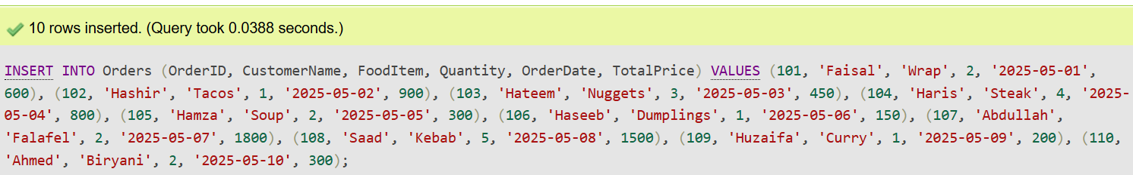
(110, 'Ahmed', 'Biryani', 2, '2025-05-10', 300);

Figure 11.6 : Values Inserted

Q.6: Update the delivery status of the order with ID 202 to 'Delivered'.
QUERY:-
UPDATE Orders SET DeliveryStatus = 'Delivered' WHERE OrderID = 202;
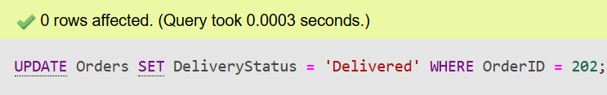

Figure 11.7 : Values Updated where Status = Delivered and Id= 202

Q.7: Delete any orders where the quantity is greater than 3.
QUERY:-
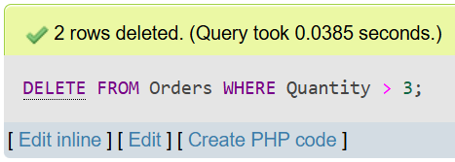
DELETE FROM Orders WHERE Quantity > 3;

Figure 11.8 : Values Deleted Where Quantity > 3

Q.8: Select and display all delivered orders, ordered by total price from
highest to lowest.
QUERY:-
SELECT * FROM Orders
WHERE DeliveryStatus = 'Delivered'
ORDER BY TotalPrice DESC;
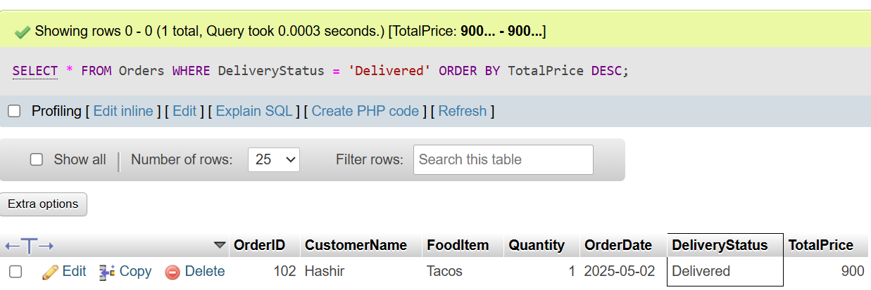

Figure 11.8 : Values Sorted

Q.9: Drop the Orders table.
QUERY:-
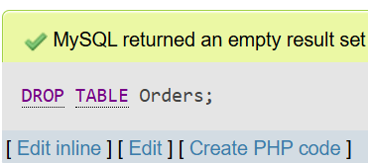
DROP TABLE Orders;

Figure 11.9 : Order Table Dropped
Scenario 2: Hospital Management
Q.1: Create a database called HospitalDB and select it for use.
QUERY:-
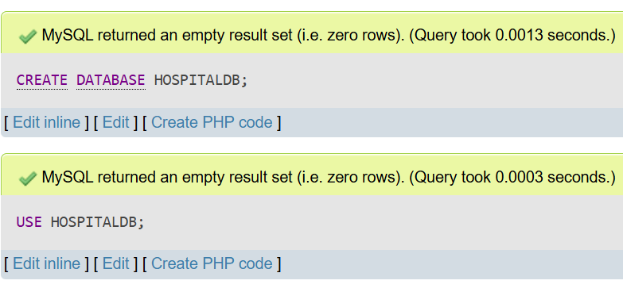
CREATE DATABASE HOSPITALDB;

Figure 11.10 : Hospital Database Created

Q.2: Create a table named Patients with fields for patient ID, full name, age, gender, and admission date.
- The PatientID is the primary key.
- Age must be 0 or higher (using a CHECK constraint).
- AdmissionDate cannot be null.
QUERY:-
CREATE TABLE Patients (
PatientID INT PRIMARY KEY,
FullName VARCHAR(100),
Age INT CHECK (Age >= 0),
Gender VARCHAR(10),
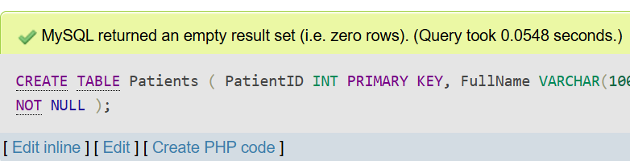
AdmissionDate DATE NOT NULL );

Figure 11.11 : Patients Table Created
Q.3: Show all available databases and all tables inside the selected database.
QUERY:-
SHOW DATABASES;
SHOW TABLES FROM HOSPITALDB;
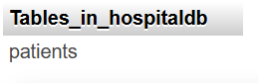
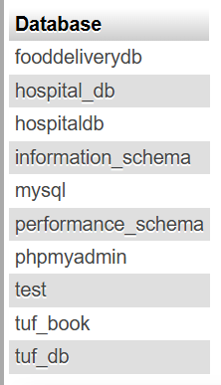

Figure 11.12 : Databases and Tables Shows

Q.4: Add a new column called BloodGroup to the Patients table.
QUERY:-
ALTER TABLE Patients ADD COLUMN BloodGroup VARCHAR(5);
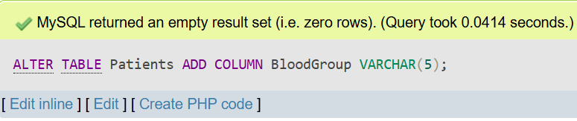

Figure 11.13 : Table Altered

Q.5: Insert ten patient records into the Patients table with relevant details.
QUERY:-
INSERT INTO Patients
VALUES
(1, 'Faisal', 30, 'Male', '2025-06-01', 'B+'),
(2, 'Hashir', 26, 'Male', '2025-06-02', 'O-'),
(3, 'Hateem', 34, 'Male', '2025-06-03', 'A-'),
(4, 'Haris', 22, 'Male', '2025-06-04', 'AB+'),
(5, 'Hamza', 40, 'Male', '2025-06-05', 'O+'),
(6, 'Haseeb', 29, 'Male', '2025-06-06', 'A+'),
(7, 'Abdullah', 33, 'Male', '2025-06-07', 'B-'),
(8, 'Saad', 25, 'Male', '2025-06-08', 'AB-'),
(9, 'Huzaifa', 31, 'Male', '2025-06-09', 'A+'),
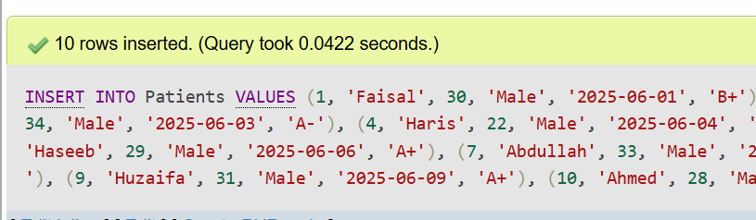
(10, 'Ahmed', 28, 'Male', '2025-06-10', 'O+');

Figure 11.14 : Values Inserted

Q.6: Update the age of the patient with PatientID = 1 by changing it to 46.
QUERY:-
UPDATE Patients SET Age = 46 WHERE PatientID = 1;
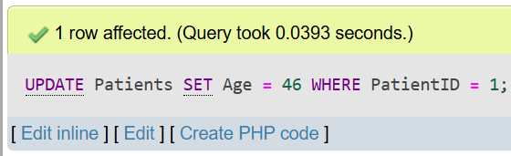

Figure 11.15 : Values Updated
Q.7: Delete the record of the patient whose gender is 'Female'.
QUERY:-
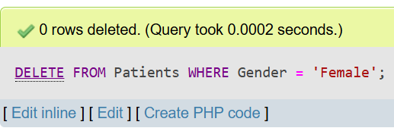
DELETE FROM Patients WHERE Gender = 'Female';

Figure 11.16 : Values Deleted where gender was female

Q.8: Select and display all patients older than 25 years, ordered by their admission date (latest first).
QUERY:-
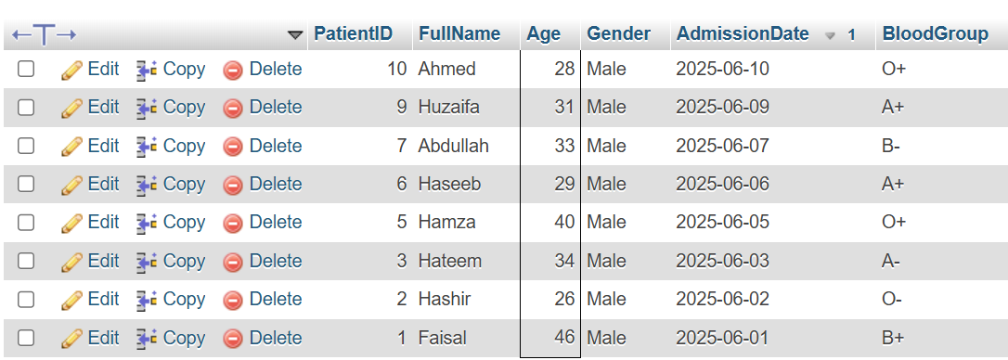
SELECT * FROM Patients WHERE Age > 25 ORDER BY AdmissionDate DESC;

Figure 11.17 : Values Sorted By Age

Q.9: Delete (Drop) the entire Patients table from the database.
QUERY:-
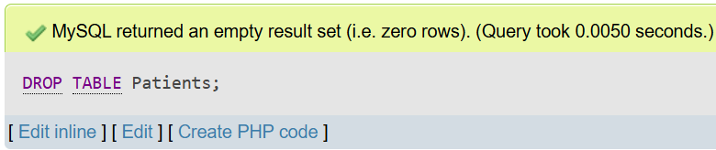
DROP TABLE PATIENTS;
Figure 11.18 : Table Dropped
Scenario 3: University Course System
Q.1: Create a database named UniversityDB and switch to it.
QUERY:-
CREATE DATABASE UniversityDB;
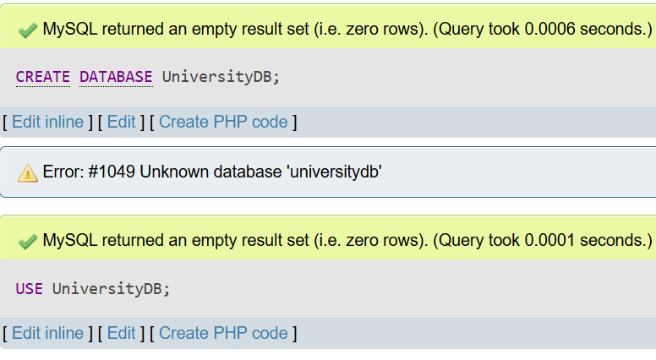
USE UniversityDB;

Figure 11.19 : Database Created and Selected

Q.2: Create a table called Courses with fields for course ID, course name, instructor, and credits.
- CourseID is the primary key.
- Credits must be between 1 and 6 (using a CHECK constraint).
QUERY:-
CREATE TABLE Courses (
CourseID INT PRIMARY KEY,
CourseName VARCHAR(100) NOT NULL,
Instructor VARCHAR(100),
Credits INT CHECK (Credits BETWEEN 1 AND 6)
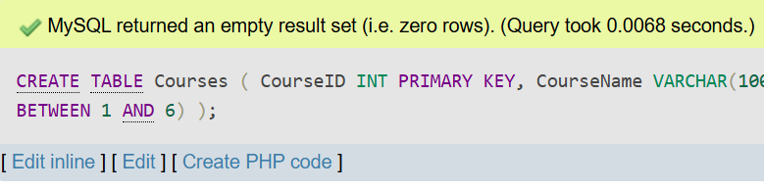
);

Figure 11.20 : Courses Table Created
Q.3: Show all databases and show tables within the UniversityDB.
QUERY:-
SHOW DATABASES;
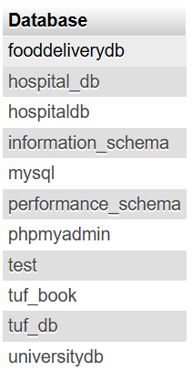
SHOW TABLES FROM UniversityDB;
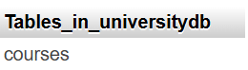

Figure 11.21 : Databases and Tables Shown

Q.4: Add a new column called Department to the Courses table.
QUERY:-
ALTER TABLE Courses ADD COLUMN Department VARCHAR(50);
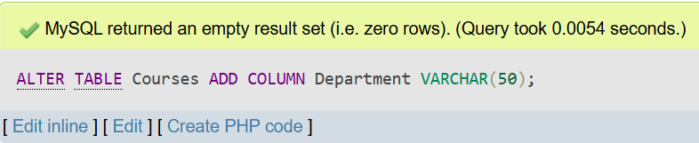

Figure 11.22 : New Column Added

Q.5: Insert ten course records into the table with course details.
QUERY:-
INSERT INTO Courses
VALUES
(101, 'Web Development', 'Prof. Khan', 3, 'Computer Science'),
(102, 'Discrete Mathematics', 'Dr. Ali', 4, 'Mathematics'),
(103, 'Modern Physics', 'Dr. Raza', 3, 'Physics'),
(104, 'Data Structures', 'Prof. Fatima', 3, 'Computer Science'),
(105, 'Numerical Methods', 'Dr. Imran', 3, 'Mathematics'),
(106, 'Organic Chemistry', 'Dr. Yasmin', 3, 'Chemistry'),
(107, 'Computer Networks', 'Prof. Naveed', 4, 'Computer Science'),
(108, 'Probability Theory', 'Dr. Saeed', 3, 'Mathematics'),
(109, 'Machine Learning', 'Dr. Farah', 3, 'Computer Science'),
(110, 'Human Anatomy', 'Dr. Kamal', 3, 'Biology');
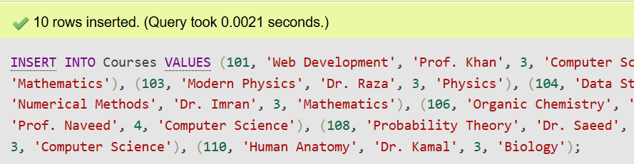

Figure 11.23 : Values Inserted

Q.6: Update the instructor’s name for the course with ID 101 to 'Dr. Alice Allen'.
QUERY:-
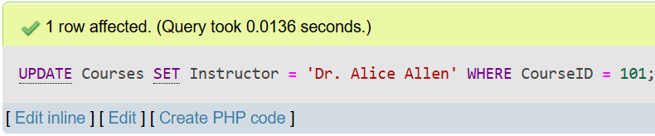
UPDATE Courses SET Instructor = 'Dr. Alice Allen' WHERE CourseID = 101;

Figure 11.24 : Values Updated
Q.7: Delete the course record where the credits are equal to 4.
QUERY:-
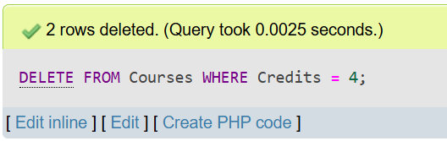
DELETE FROM Courses WHERE Credits = 4;

Figure 11.25 : Values Deleted where credits = 4

Q.8: Select and display all courses in the 'Computer Science' department, ordered by course name alphabetically.
QUERY:-
SELECT * FROM Courses WHERE Department = 'Computer Science' ORDER BY CourseName ASC;
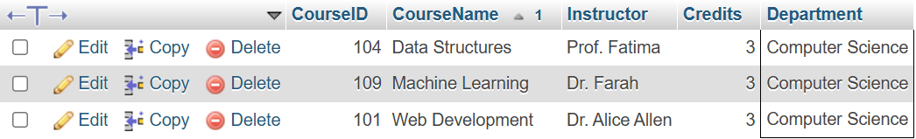

Figure 11.26 : Values Sorted By CourseName

Q.9: Drop (completely remove) the Courses table.
QUERY:-
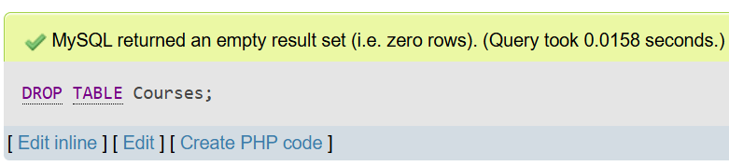
DROP TABLE Courses;
Figure 11.27: Courses Table Dropped

Lab No 12: Joins(Cross, Inner, Left, Right)
Lab Task 1: Performing Joins on Employee and Department Table

CREATE QUERY:-
CREATE TABLE EMPLOYEE(
FIRST_NAME VARCHAR(30),
LAST_NAME VARCHAR(30),
SALARY INT,
DEPARTMENT_ID INT
);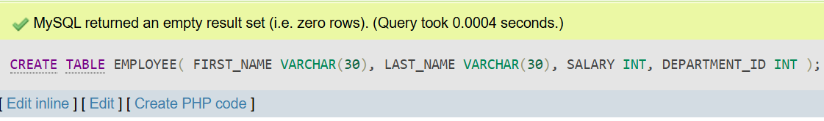
Figure 12.1: Employee Table Created

INSERT QUERY:-
INSERT INTO EMPLOYEE
VALUES
('William','Shakespare',1500,50),
('Emily','Dickinson',2700,50),
('John','Denne',3800,90),
('Oscar','Wide',4200,90);
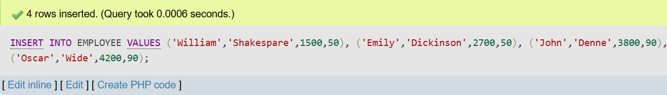
Figure 12.2: Values inserted in Employees Table

CREATE QUERY:-
CREATE TABLE DEPARTMENT(
DEPARTMENT_ID INT,
DEPARTMENT_NAME VARCHAR(40),
REGION_ID INT
);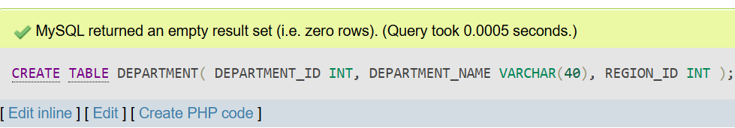
Figure 12.3: Department Table Created

INSERT QUERY:-
INSERT INTO DEPARTMENT
VALUES (50,'IT',700),
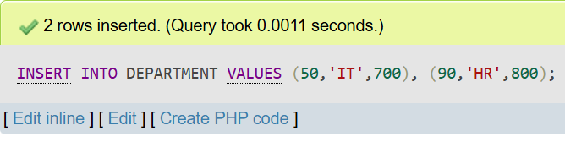
(90,'HR',800);

Figure 12.4: Values inserted in Department Table

CROSS JOIN QUERY:-
SELECT * from employee cross join department;
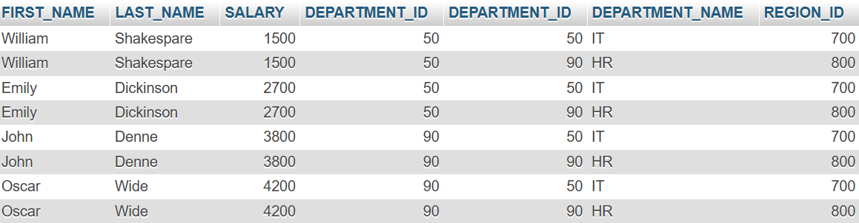
Figure 12.5: Cross Join Employee and Department
INNER JOIN QUERY:-
SELECT EMPLOYEE.FIRST_NAME, DEPARTMENT.DEPARTMENT_NAME
FROM EMPLOYEE INNER JOIN DEPARTMENT
ON EMPLOYEE.DEPARTMENT_ID = DEPARTMENT.DEPARTMENT_ID;
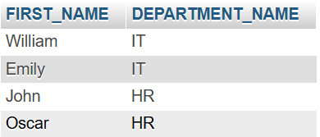

Figure 12.6: Inner Join Employee and Department

RIGHT JOIN QUERY:-
SELECT EMPLOYEE.FIRST_NAME, DEPARTMENT.DEPARTMENT_NAME
FROM EMPLOYEE RIGHT JOIN DEPARTMENT
ON EMPLOYEE.DEPARTMENT_ID = DEPARTMENT.DEPARTMENT_ID;
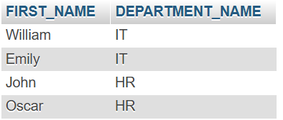

Figure 12.7: Right Join Employee and Department

LEFT JOIN QUERY:-
SELECT EMPLOYEE.FIRST_NAME, DEPARTMENT.DEPARTMENT_NAME
FROM EMPLOYEE LEFT JOIN DEPARTMENT
ON EMPLOYEE.DEPARTMENT_ID = DEPARTMENT.DEPARTMENT_ID;
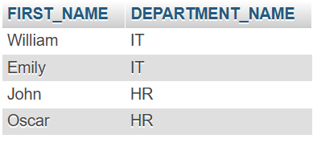

Figure 12.8: Left Join Employee and Department

LAB TASK 2: Performing Joins on Employee. Project and Client Table
INNER JOIN QUERY:-
SELECT * FROM EMPLOYEE INNER JOIN PROJECT
ON EMPLOYEE.EMPID = PROJECT.EMPID;
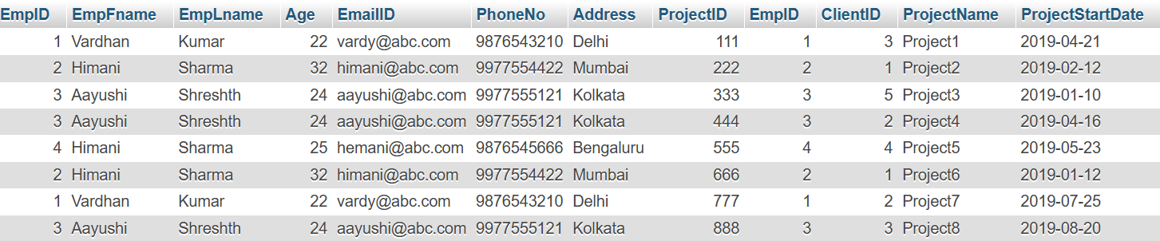
Figure 12.9: Inner Join Employee and Project

RIGHT JOIN QUERY:-
SELECT * FROM EMPLOYEE RIGHT JOIN PROJECT
ON EMPLOYEE.EMPID = PROJECT.EMPID;
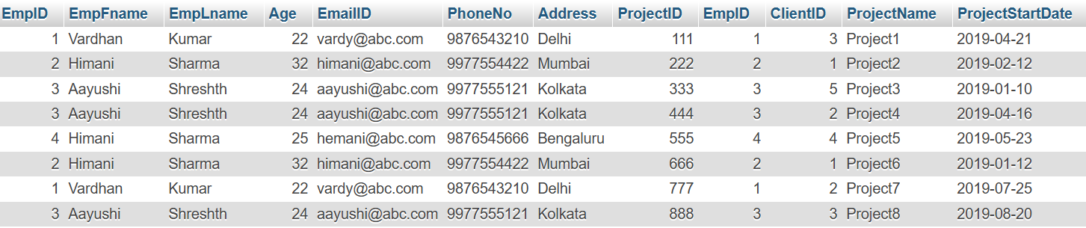
Figure 12.10: Right Join Employee and Project

LEFT JOIN QUERY:-
SELECT * FROM EMPLOYEE LEFT JOIN PROJECT
ON EMPLOYEE.EMPID = PROJECT.EMPID;
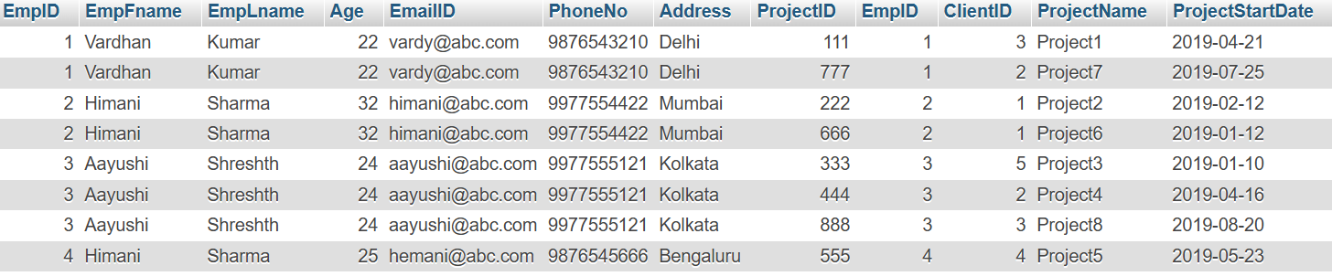
Figure 12.11: Left Join Employee and Project

INNER JOIN QUERY:-
SELECT * FROM PROJECT INNER JOIN CLIENT
ON PROJECT.EMPID = CLIENT.EMPID;
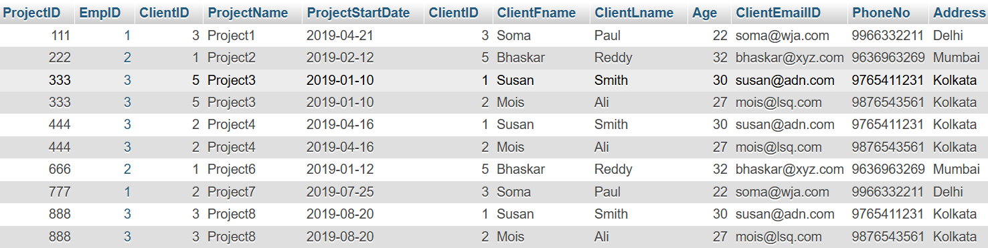

Figure 12.12: Inner Join Project and Client

RIGHT JOIN QUERY:-
SELECT * FROM PROJECT RIGHT JOIN CLIENT
ON PROJECT.EMPID = CLIENT.EMPID;
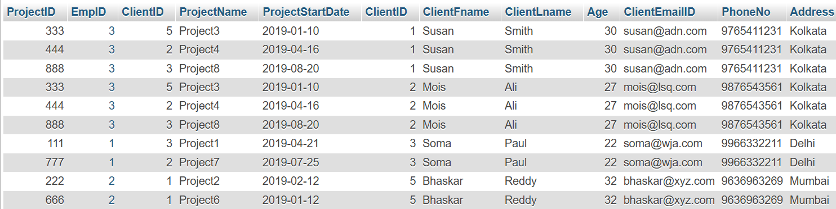

Figure 12.13: Right Join Project and Client

LEFT JOIN QUERY:-
SELECT * FROM PROJECT LEFT JOIN CLIENT
ON PROJECT.EMPID = CLIENT.EMPID;
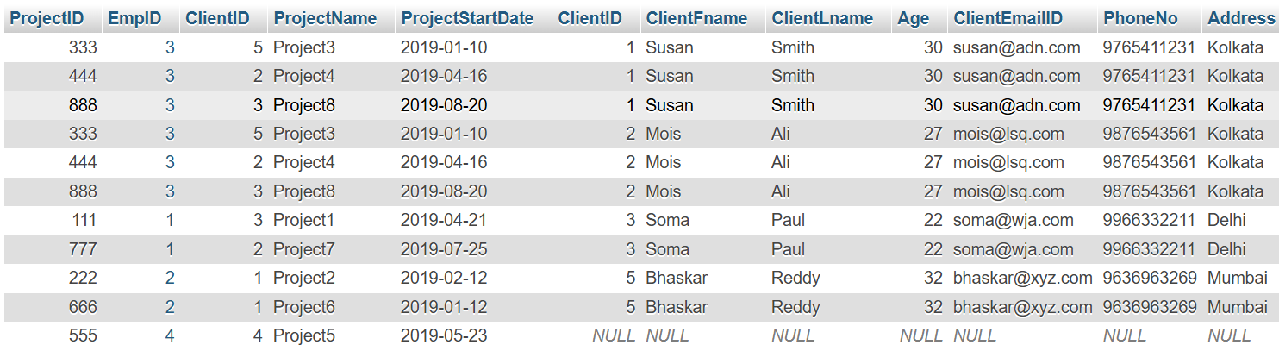

Figure 12.14: Left Join Project and Client

Lab No 13: Joins(Self and Multiple)
Task 1: Create Tables and Insert Values
CREATE QUERY:-
CREATE TABLE COACH (
ID INT PRIMARY KEY,
NAME VARCHAR(100)
);
CREATE TABLE TEAM (
ID INT PRIMARY KEY,
NAME VARCHAR(100),
COACH_ID INT,
FOREIGN KEY (COACH_ID) REFERENCES COACH(ID)
);
CREATE TABLE PLAYER (
ID INT PRIMARY KEY,
NAME VARCHAR(100),
TEAM_ID INT,
FOREIGN KEY (TEAM_ID) REFERENCES TEAM(ID)
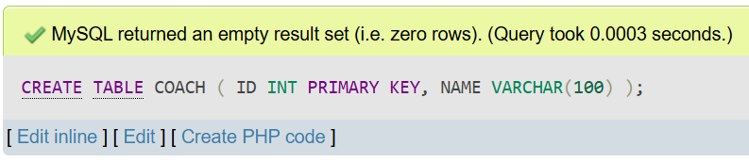
);

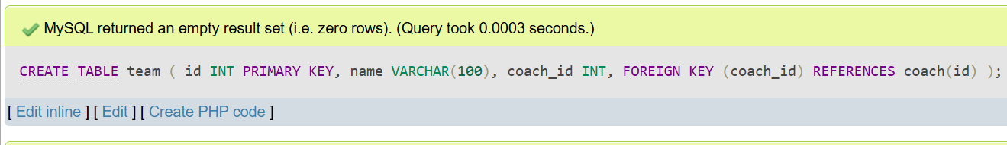

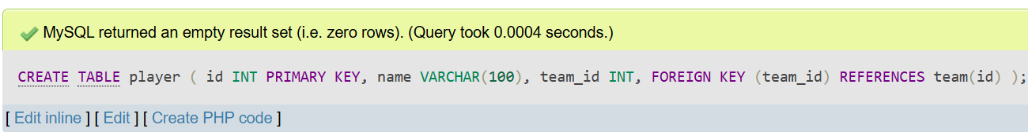

Figure 13.1 : Tables Created
INSERT QUERY:-
INSERT INTO coach (id, name) VALUES
(1, 'Mark Swanson'),
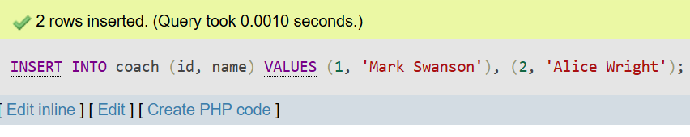
(2, 'Alice Wright');

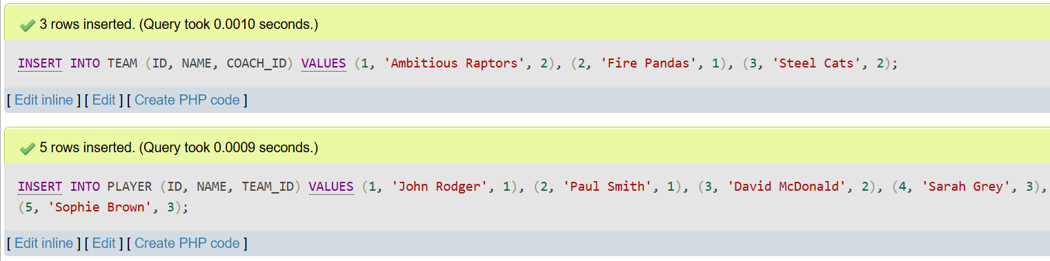
Figure 13.2 : Values Inserted

Task 2: Perform Join Operations
CROSS JOIN QUERY:-
SELECT* FROM COACH CROSS JOIN PLAYER
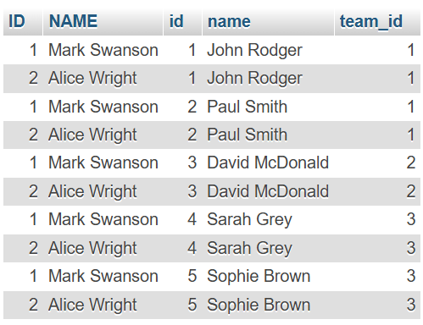

Figure 13.3 : Cross Join
INNER JOIN QUERY:-
SELECT* FROM COACH INNER JOIN TEAM
ON COACH.ID = TEAM.COACH_ID
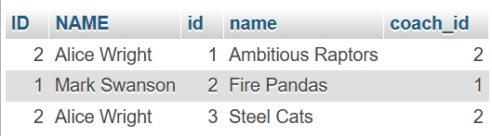

Figure 13.4 : Inner Join

LEFT JOIN QUERY:-
SELECT* FROM COACH LEFT JOIN TEAM
ON COACH.ID = TEAM.COACH_ID


Figure 13.5 : Left Join

RIGHT JOIN QUERY:-
SELECT* FROM COACH RIGHT JOIN TEAM
ON COACH.ID = TEAM.COACH_ID


Figure 13.6 : Right Join
SELF JOIN QUERY:-
SELECT
C1.ID AS COACH_ID_1, C1.NAME AS COACH_NAME_1,
C2.ID AS COACH_ID_2, C2.NAME AS COACH_NAME_2
FROM COACH C1, COACH C2
WHERE
C1.ID > C2.ID;
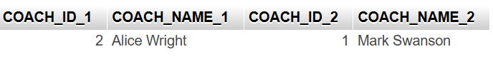

Figure 13.7 : Self Join

MULTIPLE JOIN QUERY:-
SELECT
P.NAME AS PLAYER_NAME,
T.NAME AS TEAM_NAME,
C.NAME AS COACH_NAME
FROM PLAYER P
JOIN
TEAM T ON P.TEAM_ID = T.ID
JOIN
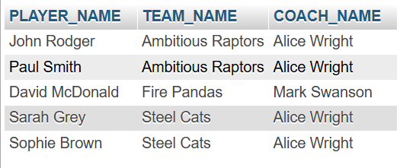
COACH C ON T.COACH_ID = C.ID;
Figure 13.8 : Multiple Join

